Adding to 100.

The wall is 100cm tall. Write how much further the climbers have to climb to get to the top.
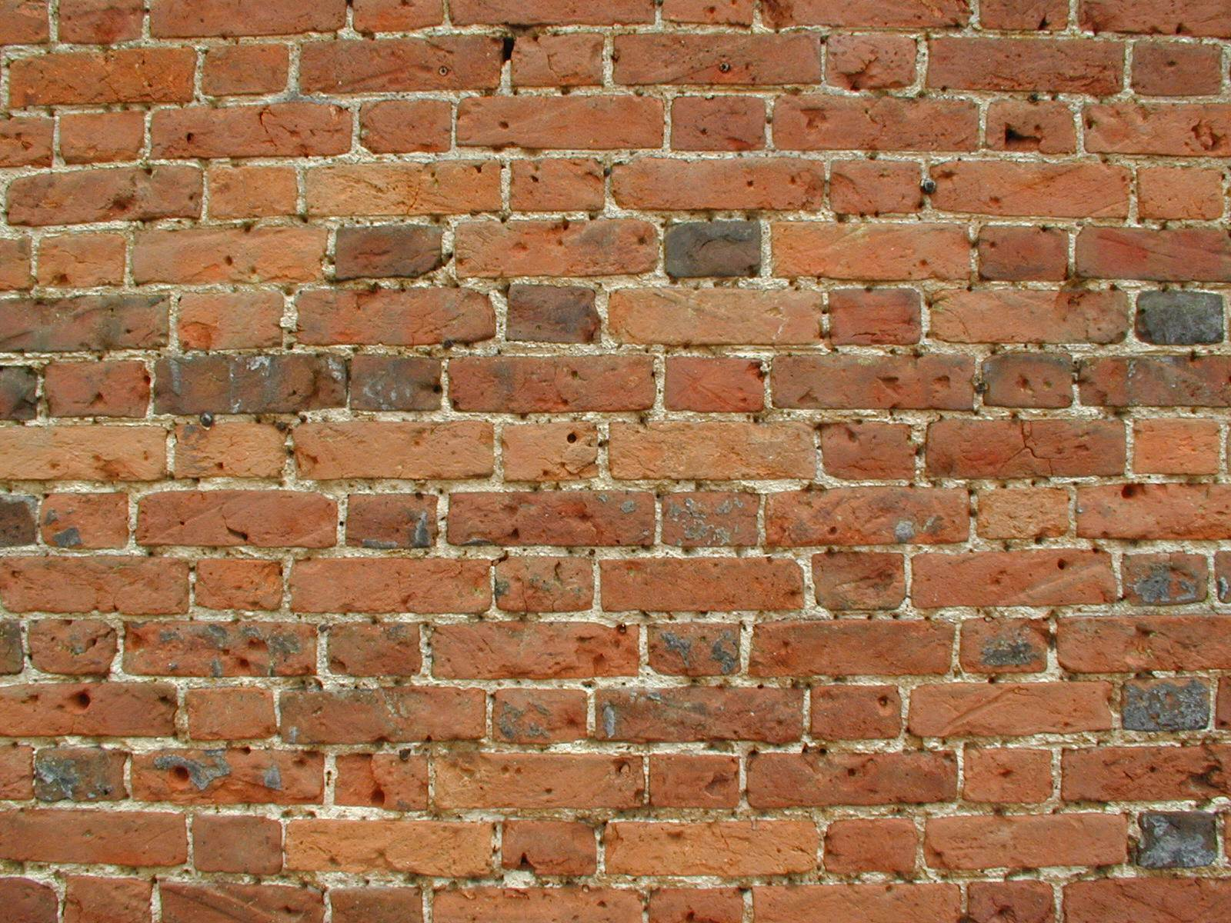
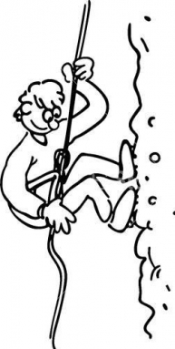
1) 89cm
2) 22cm
3) 55cm
5) 26cm
4) 94cm
6) 41cm
7) 17cm



8) 480 + = 500 11) 270 + 30 =

9) 120 + = 200 12) 460 + = 500

10) 360 + = 400 13) 350 + = 400

