Using a number line
Using a number line can help you to add two numbers
24 + 12 =
+10
+2

24 34 36

If you have two bigger numbers you can partition the number into smaller jumps:
3 3
10 3
10
10
64 + 33 =

+10
+10
+10
+3
64 74 84 94 97

Can you try the questions below:

24 + 12=

15 + 23 =

45 + 20 =

32 + 17 =

81 + 23 =

46 + 30 =

Use your 100 square to add 10 if you are struggling:
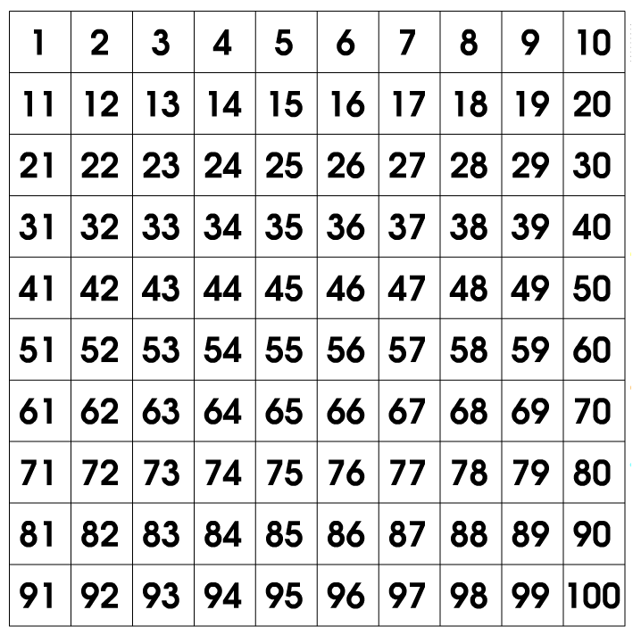

Challenge: Try adding without your 100 square!

