REAL LIFE: MASS / WEIGHT
Graph of Mass of AFL PLAYERS
- These students were weighed by the AFL manager at the beginning of the season. Make a bar graph of the results, then answer the questions.
Bob 42kg | Jamie 52kg | Neil 45kg
Wade 39kg | Sam 39kg | Bill 50kg

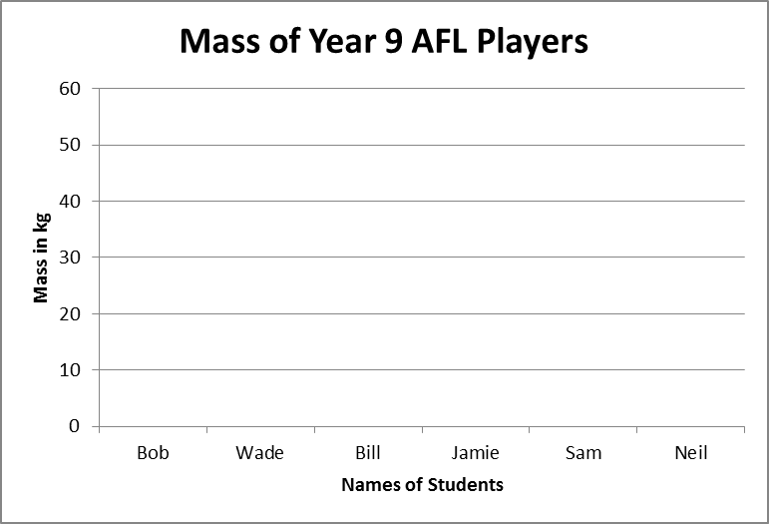

  - At the start of the season,
    - who weighed the most? ___________
    - who weighed the least? ___________
    - who had the same weight? _________
    - what was the total weight of the boys at the start of the season? _____________
- The boys’ weight at the end of the season was as follows. Put this data onto your graph in a different colour.
Bob 42kg | Jamie 52kg | Neil 45kg
Wade 39kg | Sam 39kg | Bill 50kg

  - At the end of the season,
    - who had put on the most weight? ____________. How much more did he weigh? _______
    - who had lost the most weight? _______________ How much less did he weigh? _________
    - who’s weight had stayed the same? ____________
    - What was the total weight of the boys at the end of the season? _____________

