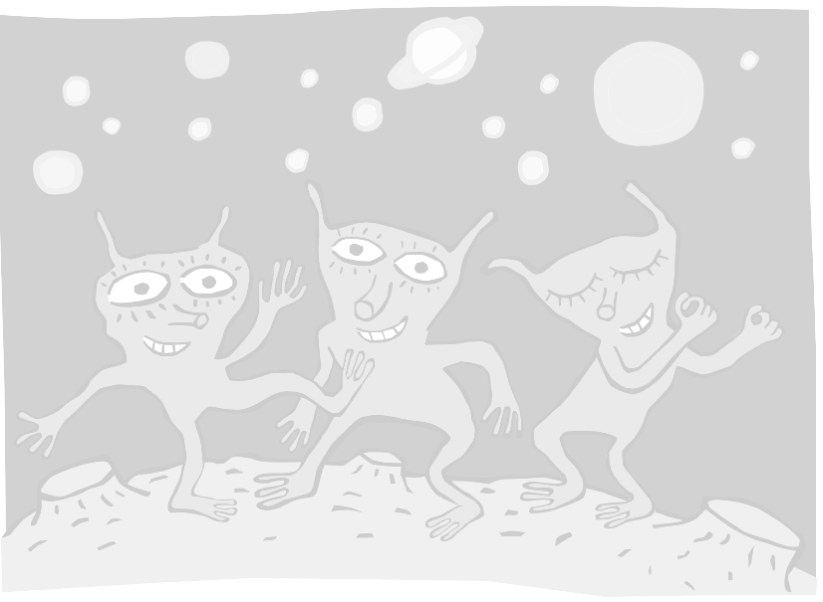
I can count, read, write and order whole numbers to at least 100.

I know all addition and subtraction facts for each number to 20.

I can multiply simple numbers.

I can divide simple numbers.

I know all addition and subtraction facts for each number to 10.

Oh No! The aliens and their spaceships have lost their colour and they can’t fly home! Can you complete your targets and colour them in to help them return to the Planet Mathsagog? They have brainwashed (teacher’s name!) and she has been told to reward you when you complete each target – I wonder how she’ll do that……
Count on or back in 10’s or 100’s from any two- or three-digit number.

Add and subtract a 'near multiple of 10' to or from a two-digit number.

Know by heart facts for the 2, 5 and 10 multiplication tables.

Understand division and recognise that division is the inverse of multiplication.

I can count, read, write and order whole numbers to at least 1000.

Oh No! The aliens and their spaceships have lost their colour and they can’t fly home! Can you complete your targets and colour them in to help them return to the Planet Mathsagog? They have brainwashed (teacher’s name!) and she has been told to reward you when you complete each target – I wonder how she’ll do that……
I can round any positive number less than 1000 to the nearest 10 or 100.

I can use number facts and place value to add or subtract mentally, including any pair of two-digit whole numbers.

I can do column addition and subtraction of two numbers less than 1000.

I know facts for the 2, 3, 4, 5 and 10 multiplication tables.

I can use symbols correctly, including less than (<), greater than (>), equals (=).

Oh No! The aliens and their spaceships have lost their colour and they can’t fly home! Can you complete your targets and colour them in to help them return to the Planet Mathsagog? They have brainwashed (teacher’s name!) and she has been told to reward you when you complete each target – I wonder how she’ll do that……

