Name: _______________________________ Date:___________________
WALT: Use angles and turns to give or follow directions

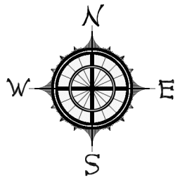
In which direction would you be facing if you turned CLOCKWISE:
- 180˚ from N _________
- 90˚ from W _________
- 90˚ from E _________
- 180˚ from W _________
- 270˚ from W _________
- 360˚ from S _________
- 270˚ from E _________
- 360˚ from N _________
- 90˚ from S _________
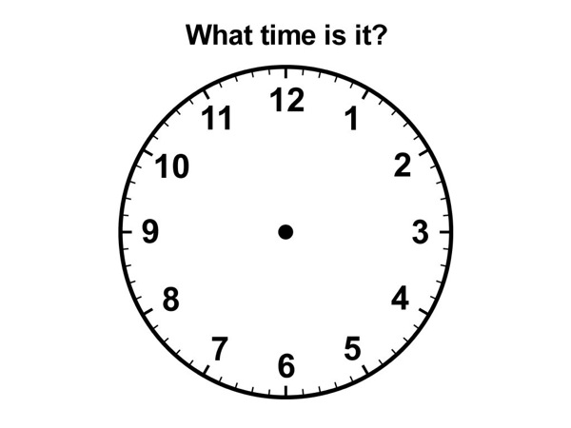
In which direction would you be facing if you turned ANTI- CLOCKWISE:
- 90˚ from E _________
- 90˚ from W _________
- 180˚ from S _________
- 180˚ from E _________
- 270˚ from S _________
- 180˚ from N _________

Find the new time if the hour hand makes a:
- CLOCKWISE half turn from 3 o’clock ______________________
- CLOCKWISE 90˚ turn from 12 o’clock ______________________
- ANTI-CLOCKWISE half turn from 12 o’clock ______________________
- CLOCKWISE quarter turn from 6 o’clock ______________________
- CLOCKWISE 180˚ turn from 11 o’clock ______________________
- ANTI-CLOCKWISE 90˚ turn from 5 o’clock ______________________
- CLOCKWISE 270˚ turn from 7 o’clock ______________________
- ANTI-CLOCKWISE 360˚ turn from 2 o’clock ______________________
- CLOCKWISE 90˚ turn from 8 o’clock ______________________
- CLOCKWISE 180˚ turn from 4 o’clock ______________________

