Year 4 Area & Perimeter
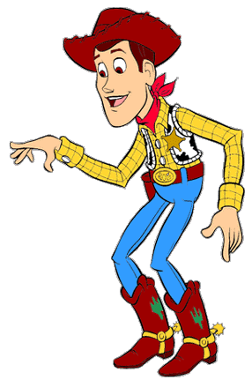
LO: To be able to find the area and perimeter of compound shapes.
I need to round up the cows in a pen. Look at these pens. I need to know how long the fence (or perimeter) is and how big they are (or area) to see how many cows they will hold, can you help?

5m
B)
A)
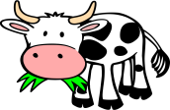
7m
9m
2m
15m
7m
5m
7m
6m
5m
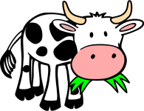
12m
12m

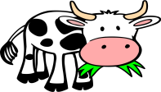
4m
C)
6m
4m
D)
6m
6m
10m
2m
14m
5m
5m
5m
2m
4m
18m
5m
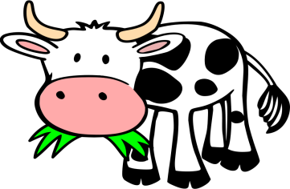
6m

10m
7m
5m
E)
F)
6m
8m
8m
12m
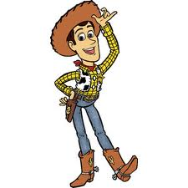
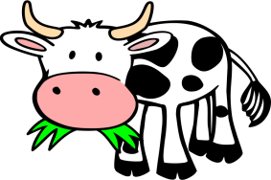
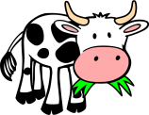
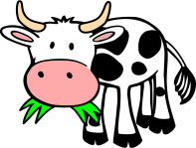
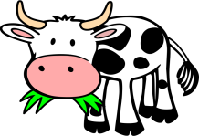
Make sure you include all the measurements. Some are missing!
17m
6m
4m

13m
6m
12m
6m
G)
H)
J)
I)
12m
32m
18m
14m
6m
12m
10m

10m
20m
25m
20m
18m
25m
35m
20m
100m
55m
15m
6m
8m

