AN INFANT SCHOOL’S FAVOURITE BEACH ACTIVITIES
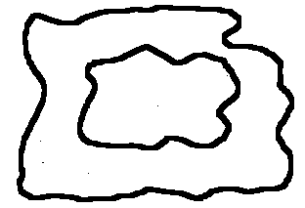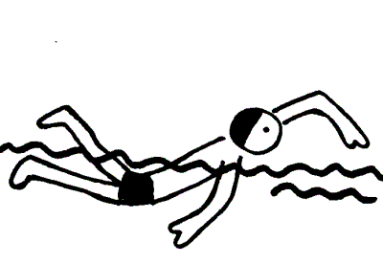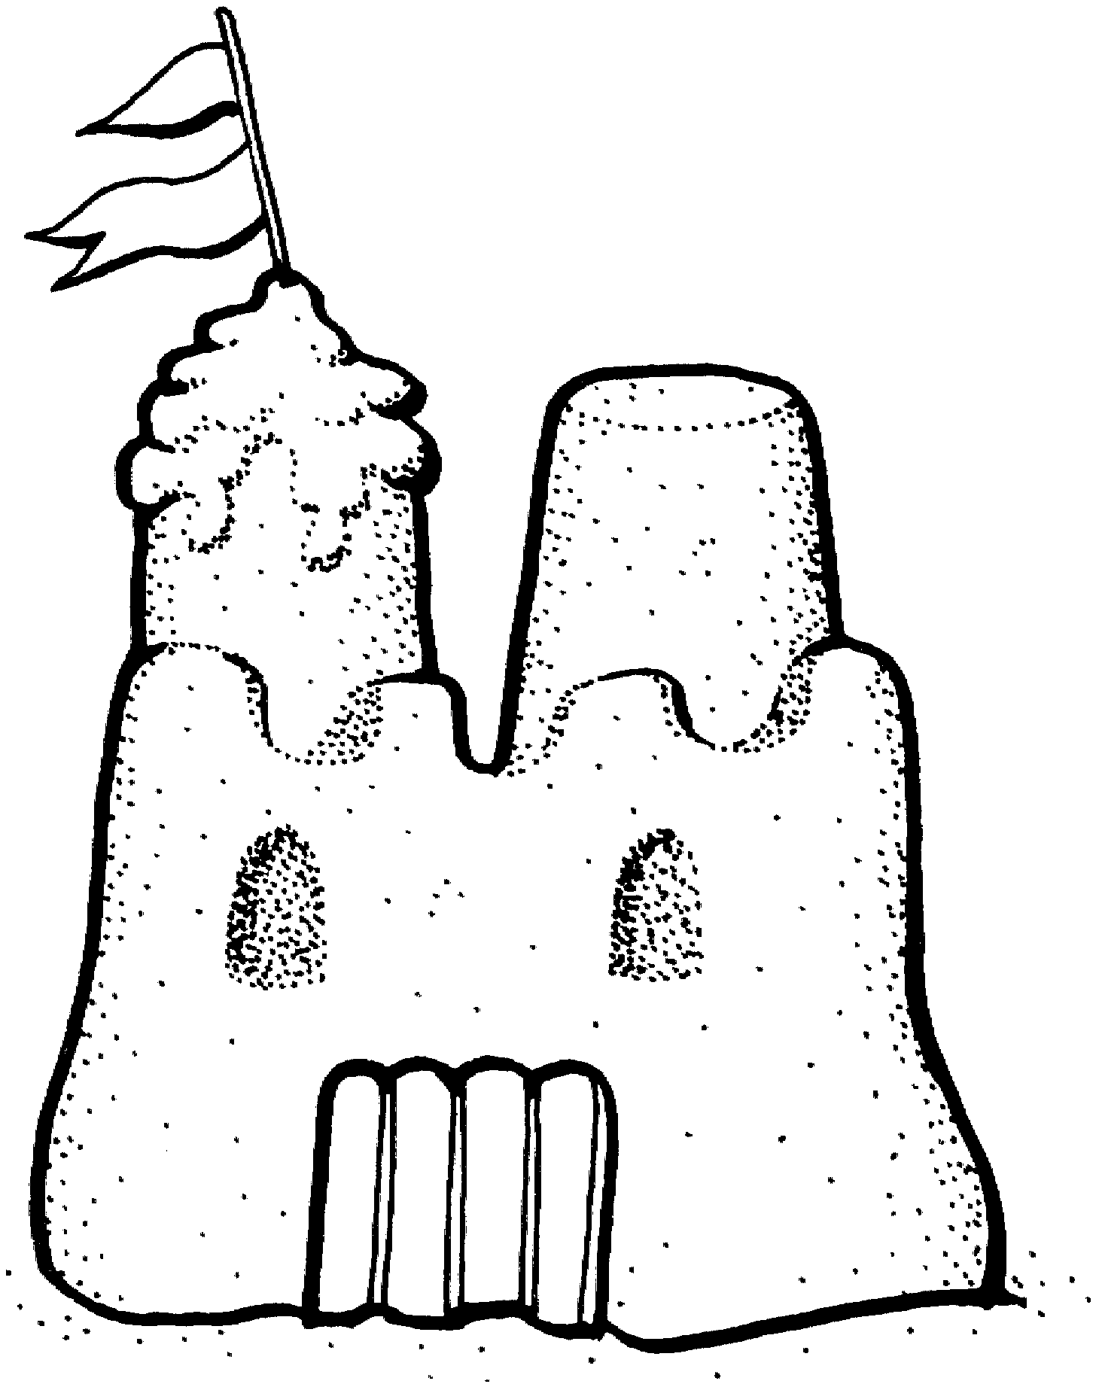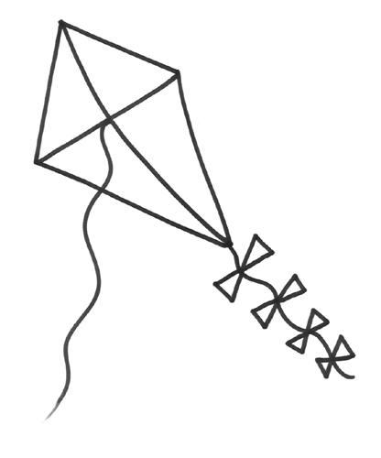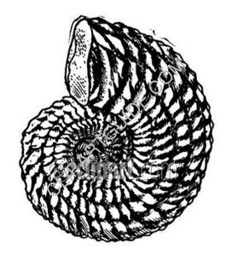

Name ______________________

Reading a Chart

1. How many children liked looking in rock-pools? ___________

2. How many children liked looking for shells? ______________

3. How many children liked flying a kit? ___________________

4. How many children liked swimming? ____________________

5. How many children liked building sandcastles? ____________

6. How many children liked flying a kite AND swimming?

____________ + _____________ = ______________

7. What activity did MOST children like? _________________

8. What activity did the LEAST children like? ______________

9. What 2 activities were liked by the same number of children?

______________________ and _______________________.
SUPER CHALLENGE:

Add together the children who like each activity to find out ho many children there are. Use a 100 Square and a whiteboard to help you!

____ + _____ + _____ + ______ + ______ = _______

Name ___________
Seaside Activities
Use the table below to draw a graph. Colour in one box for each person who like an activity.
COLLECTING SHELLS | KITE FLYING | ROCK – POOLING | BUILDING SANDCASTLES | SWIMMING
3 | 3 | 5 | 7 | 10

SHELLS SWIMMING ROCK SANDCASTLE KITE
POOL

