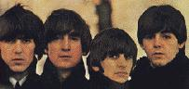

The Beatles

Year | Number of number one hit singles | Weeks at the top of charts
1963 | 4 | 18
1964 | 3 | 11
1965 | 3 | 11
1966 | 2 | 6
1967 | 2 | 10
1968 | 2 | 4
1969 | 2 | 9

Rolling Stones

Year | Number of number one hit singles | Number of top ten hits
1963 | 0 | 0
1964 | 2 | 3
1965 | 3 | 4
1966 | 1 | 2
1967 | 1 | 2
1968 | 1 | 1
1969 | 1 | 1

Find the mode, median and mean averages for each column. When you have finished find the range for each column.

The Beatles
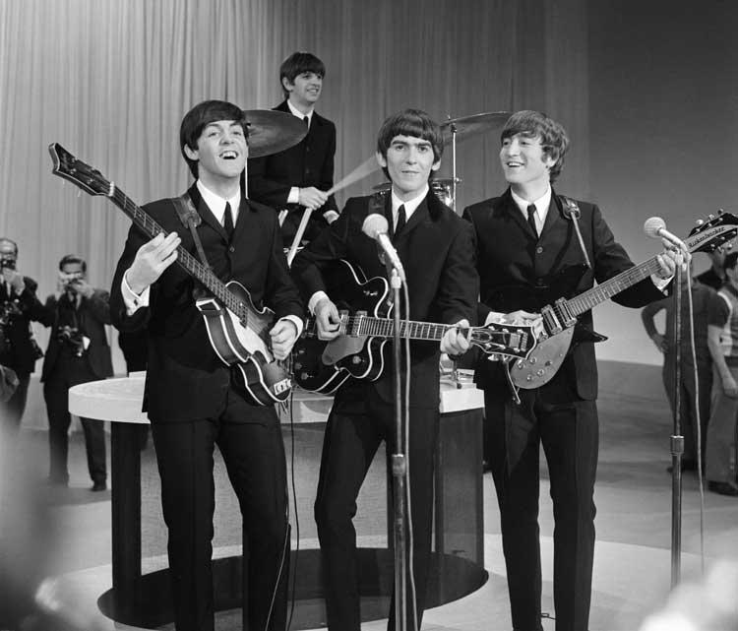

This table shows how many songs the Beatles featured on their albums.

Album title | Number of songs featured
Please Please Me | 14
With The Beatles | 14
A Hard Day’s Night | 13
Beatles For Sale | 12
Help | 14
Rubber Soul | 14
Revolver | 14
Sgt. Pepper’s Lonely Hearts Club Band | 13
Magical Mystery Tour | 11
The White Album | 30
Yellow Submarine | 15
Abbey Road | 17
Let it Be | 12

Find the mode, median and mean average number of songs included on a Beatles album.
Remember: The mode is the most common number. The median is the middle number when the numbers are placed in order of size. The mean is the total divided by the number of items in the set.

If you have time draw a graph or chart of your choice to show the data.

