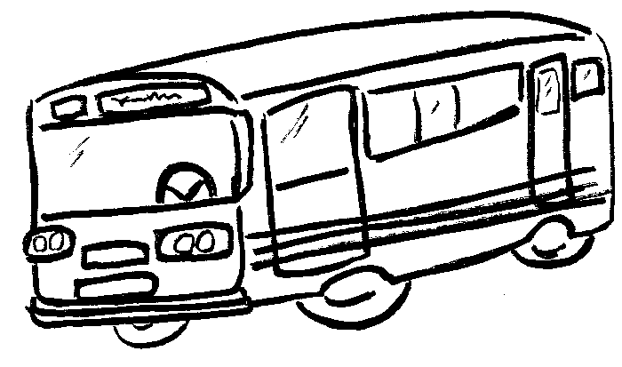
Timetables 1

Buses leave Shakespeare Junior School every 20 minutes starting at 08:00 in the morning. It takes 10 minutes to get to the railway station and a further 15 minutes to get to the airport. Complete the timetable.
Shakespeare Junior School | Eastleigh Railway Station | Southampton Airport
08:00 | 08:10
08:20 |  | 08:45
 | 08:50 | 09:05
09:00
Make your own timetable for trains from Eastleigh to Southampton. Decide how frequently they leave Eastleigh and how long it takes to get between each station. Keep these travel times regular through the day.
Eastleigh | Southampton Airport | St Denys | Southampton
07:30
Write the timetable out in your book and finish it off.

Timetables 2

Buses leave Shakespeare Junior School every 20 minutes starting at 08:00 in the morning. It takes 9 minutes to get to the railway station and a further 14 minutes to get to the airport. Complete the timetable.
Shakespeare Junior School | Eastleigh Railway Station | Southampton Airport
08:00 | 08:09
08:20 |  | 08:43
 | 08:50
09:00
Make your own timetable for trains from Eastleigh to Southampton. Decide how frequently they leave Eastleigh and how long it takes to get between each station. Keep these travel times regular throughout the day.
Eastleigh | Southampton Airport | St Denys | Southampton
07:30
Write the timetable out in your book and finish it off.

