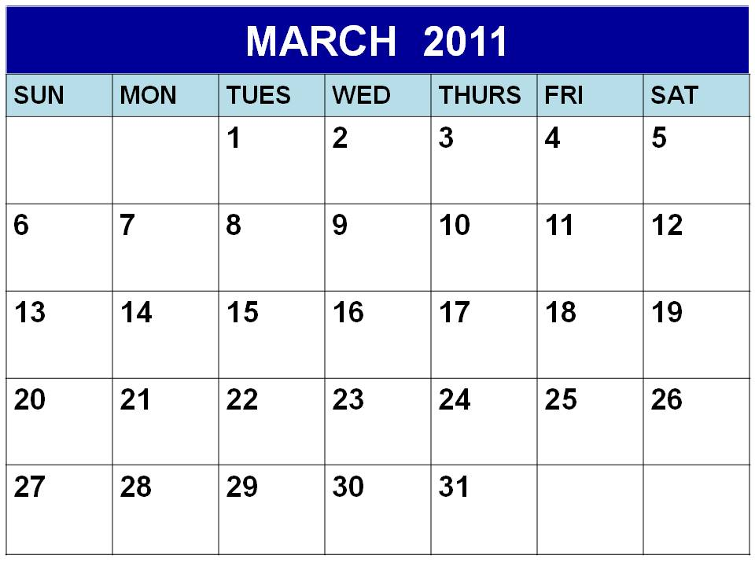
Look at the calendar and answer the questions underneath in your Numeracy books.

Days
Weeks
- What date is it today?
- How many days are in March?
- What date is before 27th March?
- What day would it be on the 24th March?
- How many Saturdays are there in March?
- What day is the 29nd March?
- What is the date a week after 17th March?
- What date is the 1st Thursday in March?
- What date is the 2nd Saturday in March?
10. Alyssa goes on holiday on the 16th March for 2 weeks. What date does she return?

Gap Task: Think of 2 questions about the calendar. Write them in your Numeracy book and swap with a partner who will try to answer them!
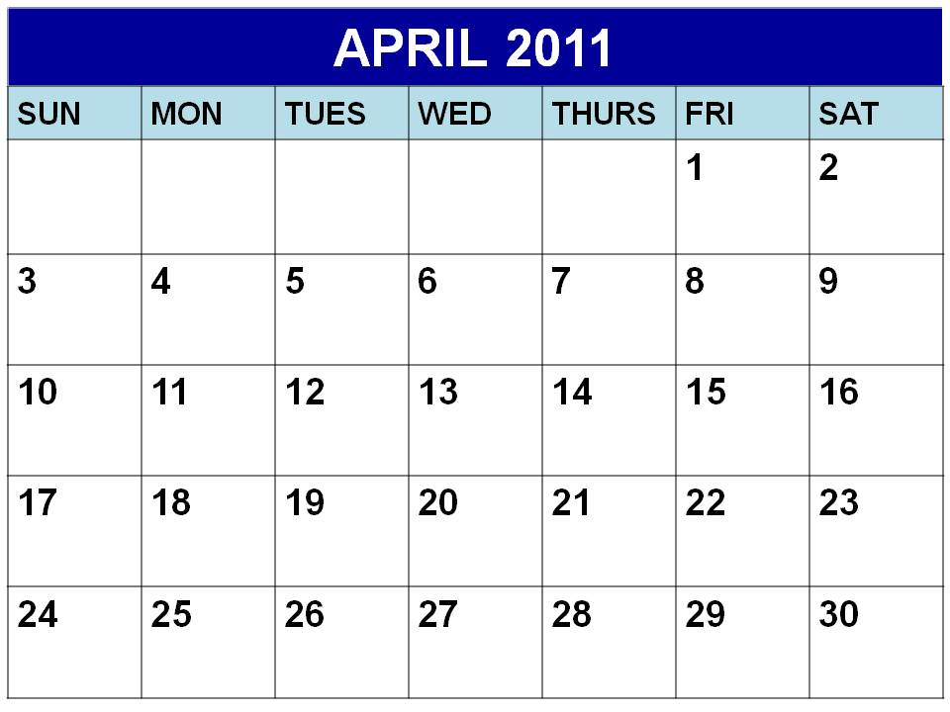
Look at the calendar and answer the questions underneath in your Numeracy books.

- What day is the 1st day of the month?
- How many days are in April?
- What date is before 27th April? What day is it?
- What day would it be on the 10th April?
- How many full weeks are in April?
- What day is the 22nd April?
- What is the date a week after 13th April?
- What date is the 2nd Thursday in April?
- What date is the 3rd Monday in April?
10. Sophie goes on holiday on the 5th April for 2 weeks. What date does she return?
11. Ethan goes on holiday the 2nd Saturday in April. What date did he leave?

Gap Task: Think of 3 questions about the calendar. Write them in your Numeracy book and swap with a partner who will try to answer them!

