CHANGE FROM 50p 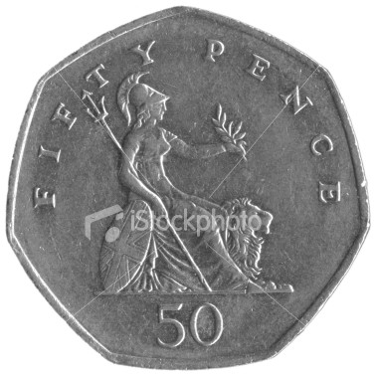

- Bouncy ball costs 42p. How much change from ?

- A Twix costs 35p. How much change from ?

- A Flake costs 37p. How much change from ?

- A rubber costs 28p. How much change from ?

- A pencil costs 21p. How much change from ?

- A kit kat costs 17p. How much change from ?

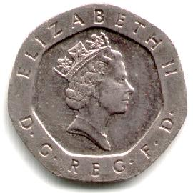
Now you have 70p. How much change will you get?
- A bracelet costs 65p. How much change from 70p?
- A ring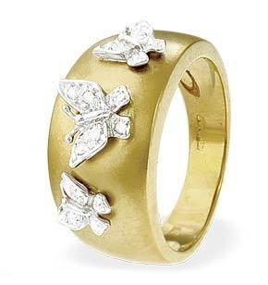costs 48p. How much change from 70p?

- A bag of chips costs 52p. How much change from 70p?
- A coke costs 44p. How much change from 70p?

Tip: Add on from the cost of what you buy to the amount of the coin/s you are spending

