L.I. To choose suitable non-standard units for measure.

Length
Cubes


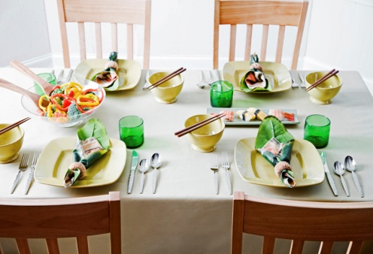
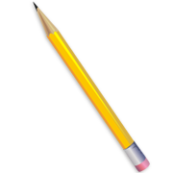

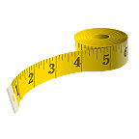
Football pitch

30cm ruler

Door
Match sticks

Table
Metre ruler

Pencil

Tape measure
Book
Weight
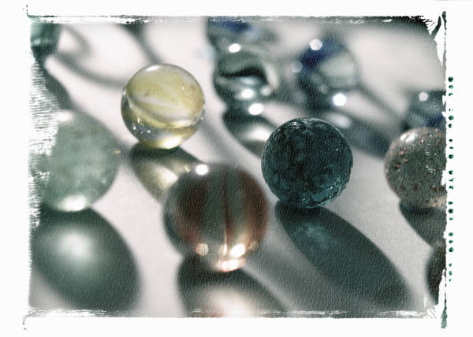

trainer
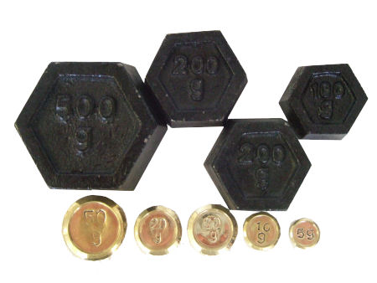
Cubes
Marbles
Gram weights

Bag of flour

Paintbrush

Book

School bag
Capacity

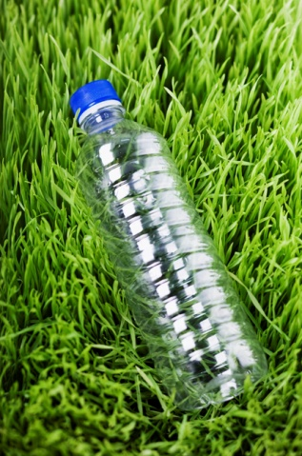

Egg cup
Bath tub

Cup
Bucket

Teapot

Measuring jug

Plastic bottle

L.I. To choose suitable non-standard units for measure.
Length

Football pitch

Door

Table

Pencil

Book

Weight

trainer

Bag of flour

Paintbrush

Book

School bag
Capacity

Bath tub

Cup

Teapot

Plastic bottle

