To be able to choose and use suitable units of measure.

Have a look at the pictures at the bottom of the page. Decide if you need to use a ruler to measure it in centimetres (cm) or a measuring jug to measure in millilitres (ml). Write them into the correct place on the venn diagram.

cm
ml

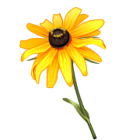
oil distance of throw water gravy key lemonade shoes tea flower
To be able to choose and use suitable units of measure.

Have a look at the pictures at the bottom of the page. Decide if you need to use a ruler to measure it in centimetres (cm), a measuring jug to measure in millilitres (ml) or grams (g). Write each one in the correct column. Some might be in more than one column.

cm | ml | g 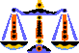
oil distance of throw water gravy key lemonade shoes tea flower

To be able to choose and use suitable units of measure.

Have a look at the pictures at the bottom of the page. Decide if you need to use a ruler to measure it in centimetres (cm) or a measuring jug to measure in millilitres (ml).

cm | ml
oil distance of throw water gravy key lemonade shoes tea flower

Put a tick if it is using the correct equipment to measure the item in the picture.

Item | Unit of measure | or 
water | cm
tea | ml
gravy | g
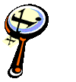 | cm
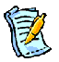 | ml
 | g
 | cm
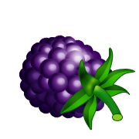 | ml
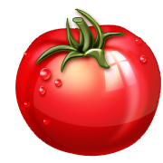 | g

