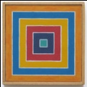

Task Sheet – all groups
Your task is to make a geometric design of concentric shapes. Measure each edge to the nearest mm and calculate the perimeter of each shape.
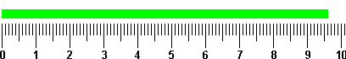
E.G.
Step 1
Draw your
First shape
Step 2
Measure each edge

Step 3
Calculate the perimeter to the nearest mm
Blue Square: 2.0cm + 2.0cm + 2.0cm + 2.0cm = 8.00cm
Step 4

Draw a second concentric shape and repeat steps 2 and 3

Green Square: 3.0cm + 3.0cm + 3.0cm + 3.0cm = 12.00cm
Step 5
Repeat several times
Step 6
Repeat with a different shape.

