Can you convert these amounts into pounds??
Write your answers in the boxes provided.

1. 56p 6. 891p

2. 516p 7. 799p

3. 143p 8. 465p

4. 8p 9. 999p

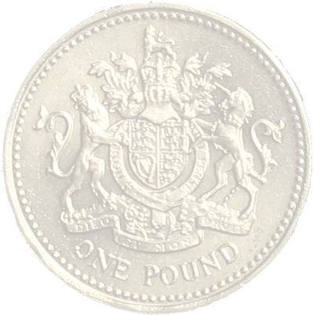

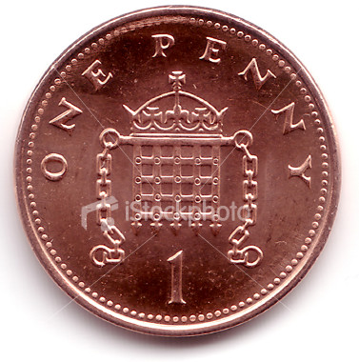
5. 39p 10. 7p

