Do I know the properties of 3D shapes?

Cut out the boxes, and match them up in your book.

 | CONE | I have 1 vertices.  I have 1 edge.  I have two faces.
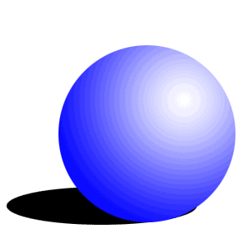 | CUBE | I have 5 vertices.  I have 8 edges.  I have 5 faces.
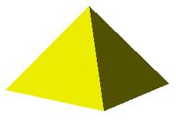 | SQUARE-BASED  PYRAMID | I have 0 vertices.  I have 0 edges.  I have 1 face.
 | SPHERE | I have 8 vertices.  I have 12 edges.  I have 6 faces.
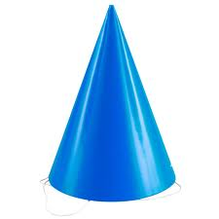 | CYLINDER | I have 0 vertices,  I have 2 edges.  I have 3 edges.

Do I know the properties of 3D shapes?
Cut out the boxes, and match them up in your book. Fill in the properties for each shape.
CONE
CUBE
SQUARE-BASED
PYRAMID
SPHERE
CYLINDER

