Year 3 Maths investigation

LO – I can collect information, construct a Bar chart and analyze my data.

1.
My chosen topic is____________________.
I am going to find out the following things
- _____________________________
- _____________________________
- _____________________________
- _____________________________

My key question is ______________________________________________________________________________.

I predict my results will show ____________________________________________________________________________________________________________________________________________________________.

2. My data

3. My results

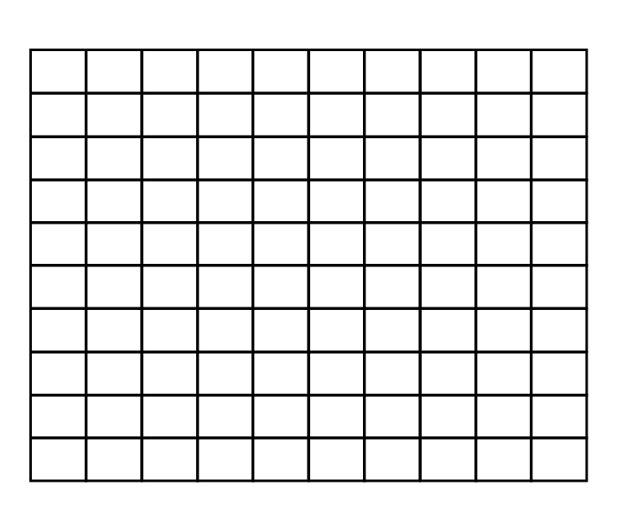

4. My findings

I have found out __________________________________________________________________________________________________________________________________

Was I right with my predictions?
____________________________________________________

