Can you label this picture of a cube?

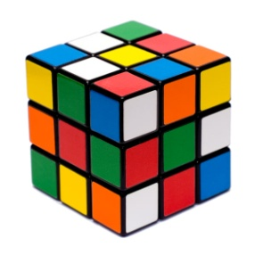

Vertex (or corner) Edge (or side) Face

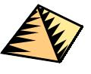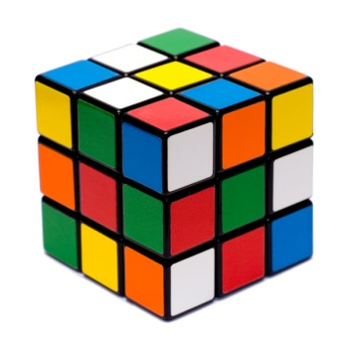C:\Users\Emily\AppData\Local\Microsoft\Windows\Temporary Internet Files\Content.IE5\YP51HWBF\MC900048285[1].wmfC:\Users\Emily\AppData\Local\Microsoft\Windows\Temporary Internet Files\Content.IE5\Y0TMYS6S\MC900048284[1].wmf**Investigation:** Can you find out how many vertices, edges and faces the following 3D shapes have?

A Cube

Vertices:

Edges:

Faces:

A Cuboid

Vertices:

Edges:

Faces:

A Pyramid

Vertices:

Edges:

Faces:

Vertices:

Edges:

Faces:

A Sphere

Vertices:

Edges:

Faces:

A Cone



A Cylinder

Vertices:

Edges:

Faces:

3D Shape Treasure Hunt

Can you find the following shapes in the playground?

Take a photo – first group back to the classroom wins!



A Cube



A Cylinder

A Cuboid



A Sphere