Eoraptor  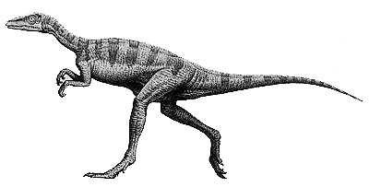 | 1m
Diplodocus  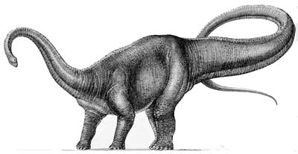 | 26m
Triceratops  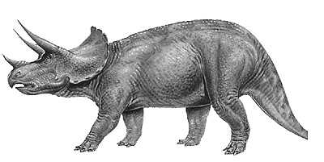 | 9m
Velociraptor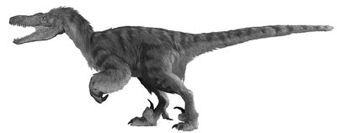 | 1.8m
Centrosaurus  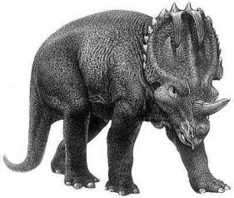 | 6.3m
Argentinosaurus  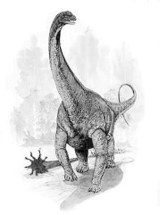 | 35m
Gigantosaurus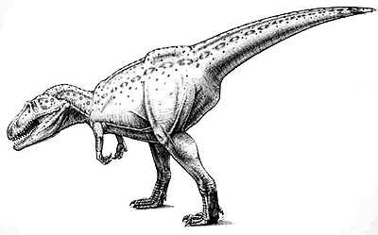 | 12.5m
Parasaurolophus  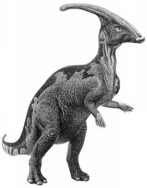 | 10.4m

Eoraptor | 1m
Diplodocus | 26m
Triceratops | 9m
Velociraptor | 1.8m
Centrosaurus | 6.3m
Argentinosaurus | 35m
Gigantosaurus | 12.5m
Parasaurolophus | 10.4m

