DIRECTIONS
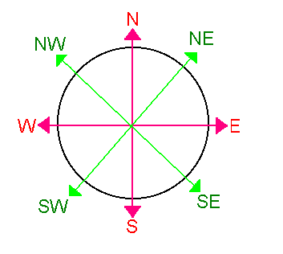

Draw diagrams to show how you find the answers to these questions.
- I am facing North, I turn 90° anticlockwise. Which direction am I now facing?
- I am facing South West. I turn anticlockwise 180°. Which direction am I now facing?
- I am facing South. I turn three right angles clockwise. Which direction am I now facing?
- I am facing North West. I turn one and a half right angles clockwise. Which direction am I now facing?
- I am facing South West. I turn 90°anti clockwise. Which direction am I now facing?

Draw diagrams to show how you find the answers to these questions.

- Reading is West of London. Portsmouth is South of Reading. What direction is London from Portsmouth?

- Bath is East of Cardiff. Gloucester is North of Bath. What direction is Gloucester from Cardiff?

- Dublin is East of Galway. Wexford is South of Dublin. What direction is Galway from Wexford?

- Edinburgh is East of Glasgow. Dundee if North of Edinburgh. What direction is Glasgow from Dundee?
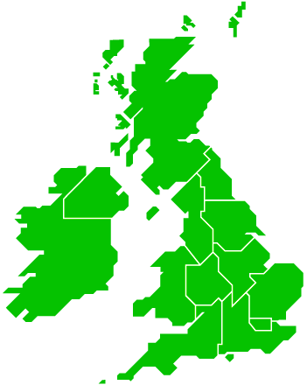

ANSWERS:
- West
- North East
- East
- East
- South East

- North East
- North East
- North West
- South West

