
We Are Learning To

Use our knowledge of doubling and halving to solve word problems
What I am Looking For:

You to use your knowledge of doubling and halving.
:
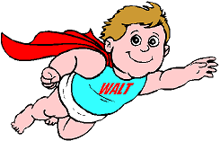

Answer the following in your book and show your workings out.

1. Gina has 6 sweets. Her sister has got twice as many.
How many sweets has Gina’s sister got?

2. A pizza is cut into 10 slices. Ben eats half of them.
How many are left?

3. In a packet of 24 pencils, half are red and half are yellow.
How many are there of each colour?

4. On Jenny’s 9th birthday her Dad, Geoff, tells her that he is doubling her pocket money. She used to get 80p a week. How much will she get now?

5. It is 8 days until Emily’s birthday. Karen will have to wait twice as long.
How many days is it until Karen’s birthday?

When are Emily and Karen’s birthdays?

Can you write a word problem for a friend to solve?

