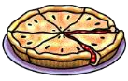
Equivalent Fractions

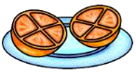
Can you work out the equivalent fractions for ½?

Remember to use the resources!

16 8 12 20 24
What about….


40 200 400

Challenge – can you do it again for ¼?

8 12 20 24

Equivalent Fractions

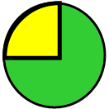
Can you work out the equivalent fractions for ¼?
Remember to use the resources!

16 8 12 20 24
What about….

40 200 400

Challenge – can you do it again for ¹/₅?

10 15 25

Equivalent Fractions

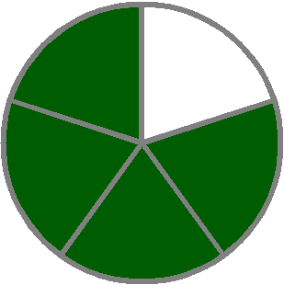
Can you work out the equivalent fractions for ¹/₅?
Remember to use the resources!

10 15 20 25 50
Any others? How could we use patterns to work some out? Write some below.

Challenge – can you find the fractions to ³/₅?

Equivalent Fractions

SUPER CHALLENGE!!

Remember to use the resources!

Can you find equivalent fractions for ¹/₁₀?

Can you find equivalent fractions to ⁵/₆?

