Equivalent Pizza Fractions
Halve the pizza slices to create equivalent fractions.

2 people share a pizza. They have 1 slice each. What fraction is each slice?  _________  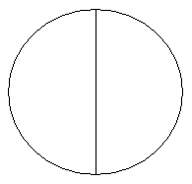  Each person wants two different toppings. Divide the pizza below correctly. What fraction is each slice?  Two more friends now join. Alter the pizza below so that each person has two slices of pizza each. What fraction is each slice?  The four friends decide to order a family size pizza so that each person can have four pieces. Draw how many slices the new pizza will have. What fraction is each slice?  _____________________________ | Can you answer these questions on equivalent fractions?  - How many   in  ?  - How many eighths in ?  - How many eighths in ?  - How many eighths in   - Hoe many sixteenths in one eighth?  - How many sixteenths in three eighths?  - How many sixteenths in ?  - How many sixteenths in ?  - How many s is twelve sixteenths?  - write the fractions that are equivalent to:  _______________________________________  _______________________________________  _______________________________________
Write a rule for what happens to each pizza slice fraction each time the pizza slice is halved: ______________________________________________________________________________________
______________________________________________________________________________________
______________________________________________________________________________________

Equivalent Cheesecake Fractions
Halve the cheesecake slices to create equivalent fractions.

Miss Crawford shares her cake with Mrs Murphy and Mrs Croasdale. What fraction is each slice?  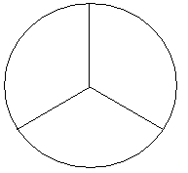Halve each of the slices in the cheesecakes below to create further equivalent fractions (clue: the next ones are sixths!).  Fractions:_________  Fractions:_________  Fractions:_________ | In the pizza below write fractions equivalent to .  Remember to use both sides to the worksheet to help you. (Clue: look at any even numbered fractions).
 | In the cheesecake below write in any fractions equivalent to 1/3. Remember to use both sides of the work sheet to help you!

