We are learning how to estimate.

1) How many colouring pencils are in the pot? Estimate ___ Actual number ___

2) I estimate that _____ coloured pens are in the pot. The actual number is ___

3) My estimate for the number of counters there are in the box is ____. The real number is _____.

4) How many pages are in the book of Not Now Bernard?
Estimate ____Number _____

5) Look at the line below. Write on where you estimate the number 6 would be.
0 ---------------------------------------------------------------10

6) Look at the line below. Write on where you estimate the number 40 would be.
0 ---------------------------------------------------------------100

7) Look at the line below. Write on where you estimate the number 10 would be.
0 ---------------------------------------------------------------100

8) Look at the picture below. Estimate how many Smarties there are.
Estimate ________ Actual amount _____

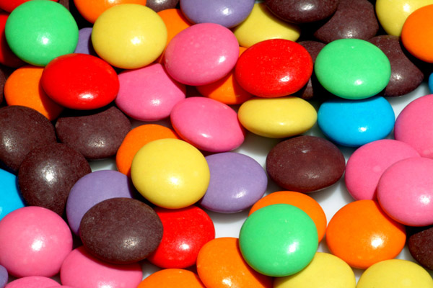

9) Pour yourself a cup of water. Estimate how much water is in the cup _____.
Now measure the amount of water in the cup _______.

10) Estimate the height of your teacher _______. Now measure the height of your teacher_________.

11) Estimate the mass of your shoe ________. Now measure the mass of your shoe________.

