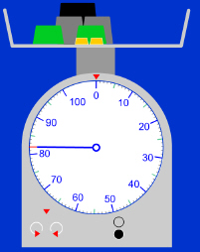
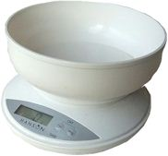
Measuring Mass

Draw and label the container | What weight do you think it is (g)? | What is the real weight (g)?
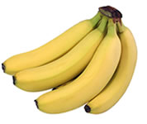  E.g.  bananas | 500g | 600g

Measuring Mass

Draw and label the container | What weight do you think it is (g)? | What is the real weight (g)?
E.g.  bananas | 500g | 600g
Which food is heaviest?_________________________________________________________________

Which food is lightest? _________________________________________________________________

Measuring Mass

Draw and label the container | What weight do you think it is (g)? | What is the real weight (g)? | What is the difference between your estimate and the real weight? | Can you convert the amount into g or kg?
E.g.  bananas | 500g | 600g | 100g | 0.6kg
Which food is heaviest?_________________________________________________________________

Which food is lightest? _________________________________________________________________

