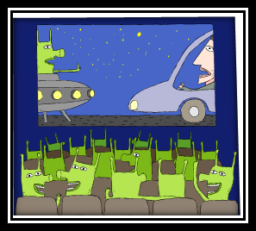
Name_________________

Alien’s Movie
Plan a movie for Mr Alien. His bank on his planet will only give him a budget of £800. Can you get him everything he needs and not spend more than his budget?
Remember, he wants the movie to be fun, exciting and have lots of props. Good luck!
In your groups use the following pages to plan what Mr Alien needs to make his film.
You must:
- Choose 1 set from the list
- Choose at least 2 actors from the list
- Choose at least 1 advertising pack from the list
- Choose as many items from the props list
MOST IMPORTANTLY – WORK AS A TEAM!
YOU HAVE A BUDGET OF £800
Don’t exceed (go over) your budget!

You may use a calculator if you wish. Please write down any working out on these sheets.

SETS
You need to choose at least one set from this list.
The film will take 2 full weeks to make
Name | Details | Price | Notes
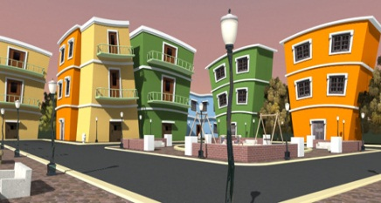  Cartoon City | - 25% off total cost per day if hired for more than 7 days  - To store your props add £5 per day | £10 per day
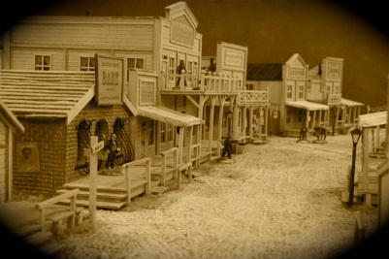  Wild West | - 50% off total cost per day if hired for more than 10 days  - To store your props minus £3 per day | Price
 |  | £26 per day
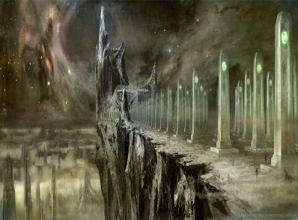  Sci-Fi Central | - 10% off total cost per day if hired for more than 7 days  - To store your props minus £2 per day | Price
 |  | £20 per day
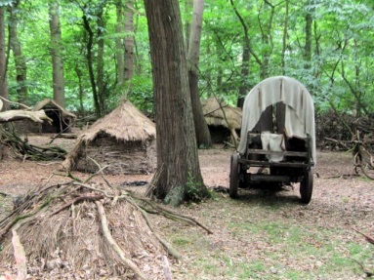  Forest Films | - 20% off total cost per day if hired for more than 7 days  - To store your props add £4 per day | Price
 |  | £17 per day
Notes

Actors & Actresses
You need to choose at least two people from this list
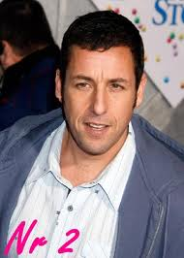  Adam Sandler  £10 per day  Add 50p per day for lunch money | 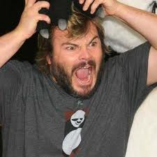  Jack Black  £11.50 per day  Lunch is £3 per day
  Amy Adams  £11 per day  Add £1 per day for lunch money | 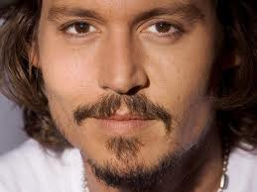  Johnny Depp  £15 per day  Lunch is £1.50 per day
  Angelina Jolie  £14 per day  Add £2.50 per day for lunch money  50% off total salary if she works with Brad | 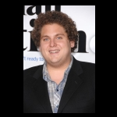  Jonah Hill  £10 per day  Lunch is £2 per day
Brad Pitt  £14 per day  Add £3 per day for lunch money  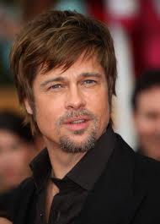  Works for just lunch money if working with Mr Bean | Mr Bean  £10 per day  Will work for 50% less per day if Brad Pitt is NOT in the film  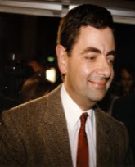  He brings a sandwich
Naomi Watts  £8 per day  Add £1 per day for lunch money    Take away £4 per day from total cost if she works with a male actor |   Natalie Portman  £9 per day  Minus £1 per day if works with Mr Bean  She brings her own lunch
Notes

ADVERTISING PACKS
Choose at least one advertising pack
Advertising Pack | Details | Price
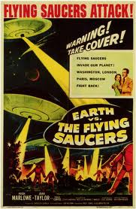  Pack A | Includes:  Movie trailer  Movie posters  Movie Website  Movie Facebook Page | £55
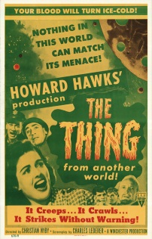  Pack B | Includes:  Interviews with actors on the news  Interviews with actors on the TV  Movie posters | £25
  Pack C | Includes:  Movie trailer  Movie posters  Movie Website  Movie Facebook Page  Large advertising billboards/posters by roads | £75

PROPS
You can choose as much as you want from this list. You just pay once for these, not per day.
Remember to keep within your budget!
Item | Details | Price | Tick
Wave machine | Uses cams to move waves | £10.00
Spaceship | Has levers, cams and pulleys for movable parts | £75.00
Alien costumes | Full set for all actors | £25.00
Cowboy costumes | Full set for all actors | £25.00
Custom costumes | Full set for all actors – DESIGN YOUR OWN | £28.00
Wizard costumes | Full set for all actors | £20.00
Large robotic spider | Has movable legs and fangs | £14.00
Large robotic horse | Can also be pushed along on wheels | £17.00
Green screen | For filming against amazing scenery | £80.00
Forrest scenery | Trees come with free oversized woodland animals | £15.00
Woodland animals | Real life animals but they may make a mess | £14.00
Princess castle | Add a bit of sparkle | £50.00
Car | Price is per one car | £30.00
Motorbike | Price is per one motorbike | £25.00
Caravan | Price is per one caravan | £2.50
Horse and Cart | Real life horse and one wooden cart | £15.00
Lighting | Set the scene to night or day | £35.00
Sound effects | Add drama and tension to your film | £72.00
Army Tank | Price is per tank | £28.00
Fireworks | Start your film off with a bang | £35.00
Design a weapon | Design weapons of your choice for your actors | £30.00
Tiny buildings | Make your actors look like giants | £68.00
Animation Studio | Add animated effects to your movie | £100.00
BUDGET PLANNER
 | Cost | Total Cost
Sets

Actors

Advertising

Props

Final Cost of Film ___________
Amount over or under budget_______________

