Finding 10 less

Learning objective: To be able to work out 10 less than any given number.

Work out what 10 less of these numbers are:

10 less than 20 = _______ 10 less than 30 = _______

10 less than 60 = _______ 10 less than 70 = _______

10 less than 10 = _______ 10 less than 90 = _______

10 less than 40 = _______ 10 less than 80 = _______

Using your number squares, work out what 10 less than these numbers are:

10 less than 44 = _______ 10 less than 12 = _______

10 less than 19 = _______ 10 less than 10 = _______

10 less than 15 = _______ 10 less than 25 = _______

10 less than 18 = _______ 10 less than 59 = _______

Finding 10 less

Learning objective: To be able to work out 10 less than any given number.

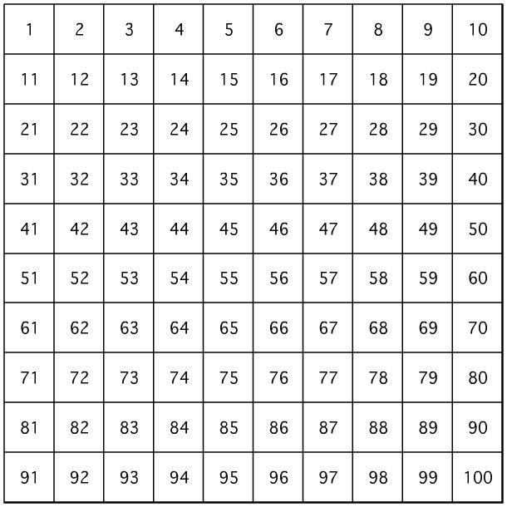

Using the number square, work out 10 less of these numbers:

10 less than 20 = _______ 10 less than 30 = _______

10 less than 60 = _______ 10 less than 70 = _______

10 less than 18 = _______ 10 less than 17 = _______

10 less than 15 = _______ 10 less than 35 = _______

10 less than 48 = _______ 10 less than 67 = _______

10 less than 12 = _______ 10 less than 98 = _______
Learning objective: To be able to work out 10 less than a number.

Number chosen: | 10 less?
25 | 15

Draw lines to match these numbers to the number that is 10 more:

10 70 25 84 46

35 20 56 80 94

