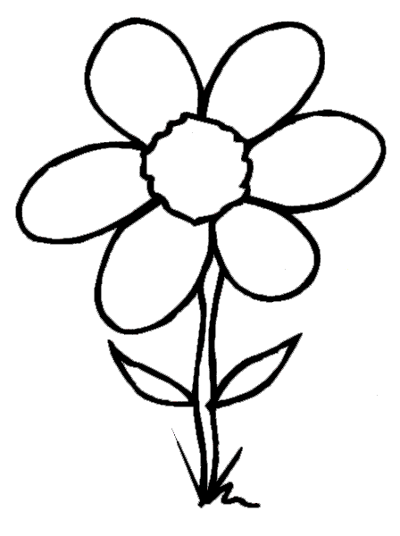
5 + 3 = _
6 + 2 =
3 + 5 =
1 + 7 =
4 + 4 = _
0 + 8 = _
5 + 7 = _
4 + 6 =
9 + 1 =
7 + 3 = _
Key:
8 = purple . 12 = yellow.
10 = green .

