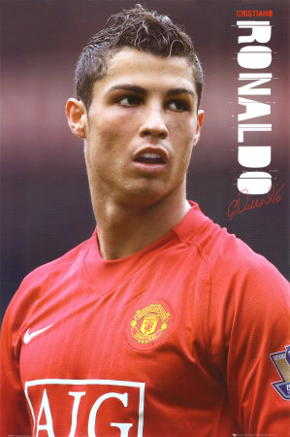
The Times Football Rich List

1. Michael Owen, £41m
2. Wayne Rooney, £35m
3. Rio Ferdinand, £28m
= 4. Frank Lampard, £19m
=4. Steven Gerrard, £19m
= 6. John Terry, £16m
7. Cristiano Ronaldo, £15m
8. Damien Duff, £14m
= 9. Didier Drogba, £13m
= 9. Harry Kewell, £13m
=11. Emile Heskey, £12m
= 11. Keiron Dyer, £12m
= 13. Ashley Cole, £11m
= 13. Joe Cole, £11m
= 13. Nicolas Anelka, £11m
= 16. Michael Essien, £9m
= 16. Craig Bellamy, £9m
=16. Robbie Keane, £9m
19. Jonathan Woodgate, £8m
20. Louis Saha, £7m
=21. Fernando Torres, £6m
=21. Jamie Carragher, £6m
=21. Shaun Wright-Phillips, £6m
=21. Cesc Fabregas, £6m
=21. William Gallas, £6m

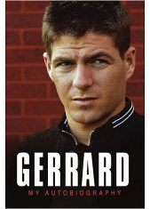

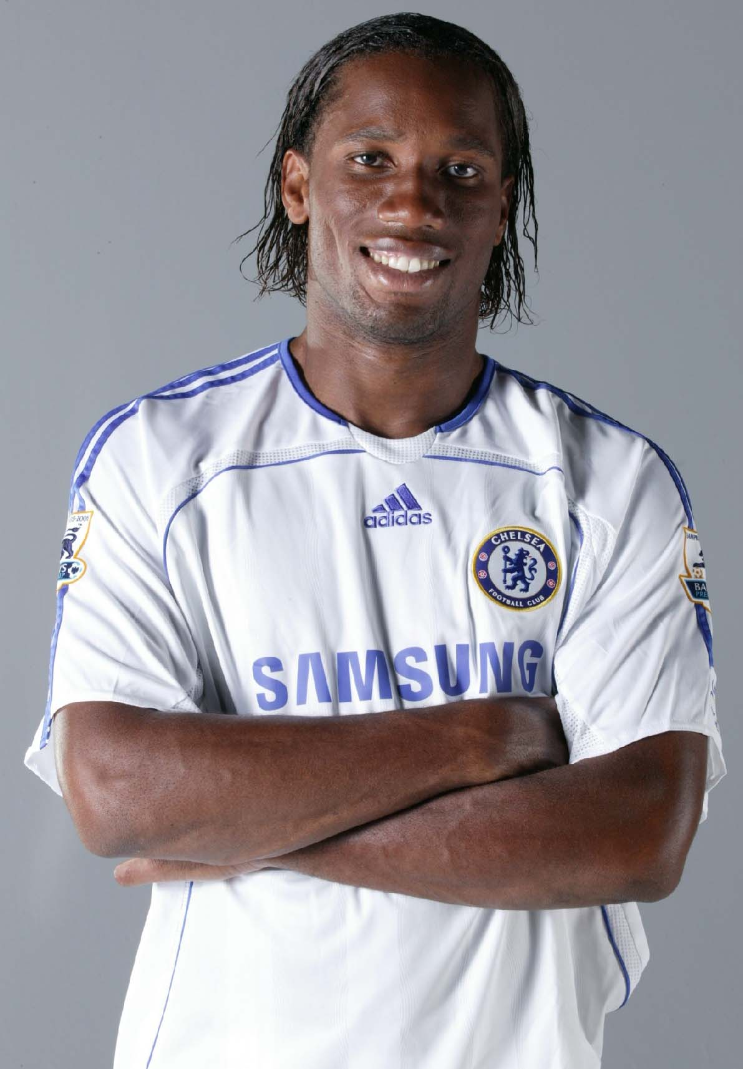
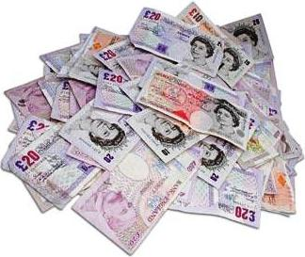

- Who is the highest paid footballer in the rich list?
- What is the difference between the top 2 footballer’s wages?
- How much does John Terry earn?
- What are the names of the 5 footballers who earn the same amount?
- How much does Stephen Gerrard earn?
- Name the footballer that earns £2 million less than £30 million.
- What is the lowest amount earned on the rich list?
- If you added Didier Drogba’s earnings to Jamie Carragher’s earnings, how much do you get in total?

