Finding a Formula for Patterns
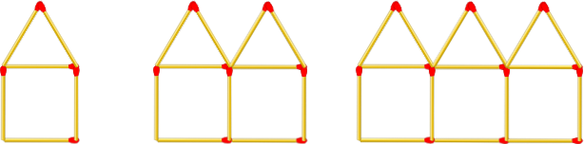

Diagram Number (n) | 1 | 2 | 3 | 4 | 5
Number of matches (p) | 6 | 11 | 16 | 21 | 26

The table above shows how many matches are needed for the three diagrams, as well as how many matches you would need if you made the 4th and 5th diagram. You should be able to see a pattern that occurs every time you add a new house.

This pattern has a rule which is: ‘We start with 6 matches, and increase by 5 matches for each diagram’.

If we want to work out how many matches we would need to make the 20th diagram, we can create a formula using this rule to work it out. This is a lot easier than drawing 20 houses and counting up all the matches.

The formula for this pattern could be: 5 x n + 1 = p (note this could be written as 5n + 1 = p)
n = the diagram number, and is also known as a variable, as it is a value that can be changed.
p = is the unknown number

When working out how many matches you would need for diagram 2, you would substitute n for 2 (the diagram number). Once you have done this, you can work out what the unknown value for p is.

For diagram 2 the formula is:
5 x n + 1 = p
5 x 2 + 1 = p (remember n stands for diagram number, so n can be substituted for 2)
5 x 2 + 1 = 11 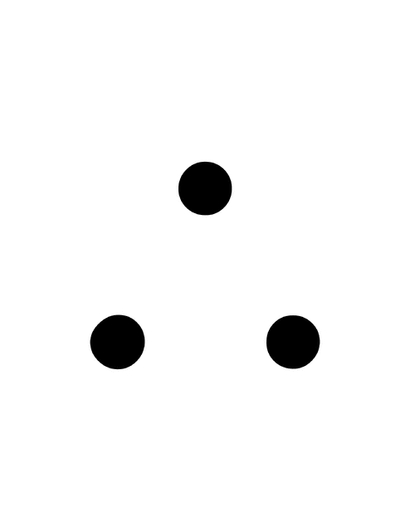 p = 11

For diagram 3
5 x n + 1 = p
5 x 3 + 1 = p
5 x 3 + 1 = 16 p = 16

If you actually drew the fourth and fifth diagrams, you should see that your formula works.
Your turn
Your task is to create a rule to show the pattern that is occurring.

A challenge is then to create a formula that will allow you to work out the missing values in the tables. There is often more than one formula that you could use. Can you find more than one??

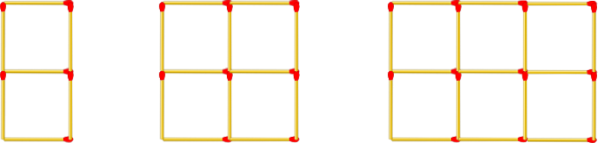

Diagram Number | 1 | 2 | 3 | 4 | 5 | 9 | 20 | 100
Number of matches | 7 | 12
Rule:
Formula:

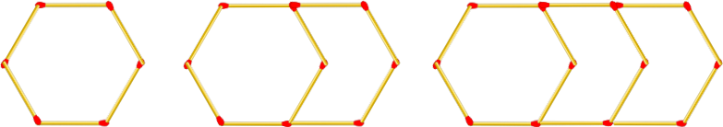

Diagram Number | 1 | 2 | 3 | 4 | 5 | 9 | 20 | 100
Number of matches
Rule:
Formula:

Extended Challenge:
Can you work out the rule and formula for the following figures?? Re draw these in your Maths books to show your working out.
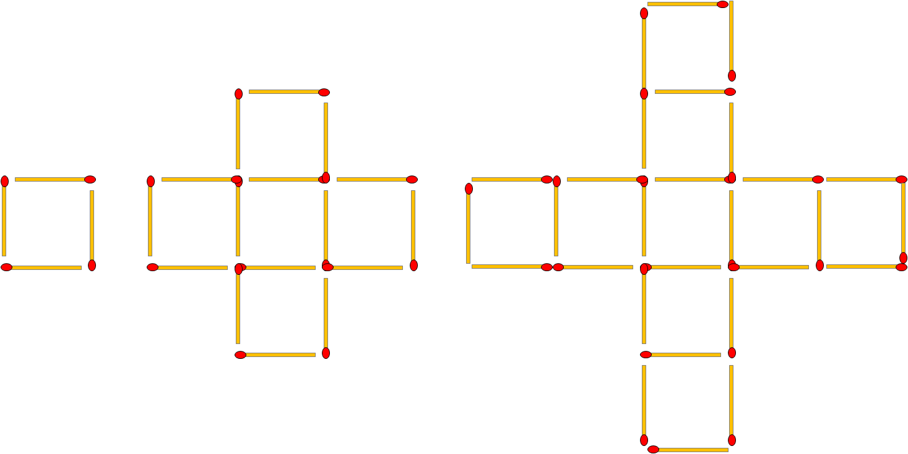
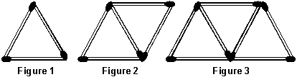
Answers
If n = diagram number (variable as it depends on the diagram number we choose)
If p = number of matches (what we are trying to create formula to find out)

1/ Rule: Start at 7 and increase by 5 each time
Possible formula: 5 x n + 2 = p (written as 5n + 2 = p)

2/ Rule: Start at 6 and increase by 4 each time
Possible formula: 4n + 2 = p

3/ Rule: Start at 4 and increase by 4 each time
Possible formula: 4n = p

4/ Rule: Start at 4 and increase by 12 each time
Possible formula: 12n – 8 = p

5/ Rule: Start at 3 and increase by 2 each time
Possible formula: 12n – 8 = p
Possible formula: 4 ( 3 (n-1) ) + 4

