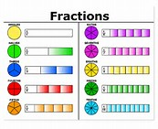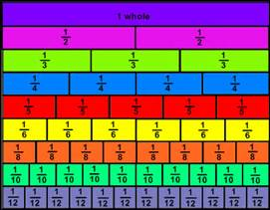
FRACTIONS

Recognising Fractions
WALTs (Learning Objectives) | SA 1 | SA 2 | TA 1 | TA 2
I can recognise, find and name a half as one of two equal parts of an object, shape or quantity
I can recognise, find and name a quarter as one of four equal parts of an object, shape or quantity
I can recognise, find, name and write fractions ¹/₃, ¼, 2/4, ¾ of a length, shape, set of objects or a quantity
I can count up and down in tenths
I recognise that tenths arise from dividing an object into ten equal parts and in dividing one digit numbers or quantities by 10
I can count up and down in hundredths
I recognise that hundredths arise from dividing an object by 100 and dividing tenths by 10

Comparing Fractions
WALTs (Learning Objectives) | SA 1 | SA 2 | TA 1 | TA 2
I can compare and order unit fractions and fractions with the same denominators
I can recognise and show, using diagrams, equivalent fractions with small denominators
I can recognise and show, using diagrams, families of common equivalent fractions

Fraction Calculations
WALTs (Learning Objectives) | SA 1 | SA 2 | TA 1 | TA 2
I can write simple fractions, e.g. ½ of 6 = 3 and recognise the equivalence of ²/₄ = ½

I can add and subtract fractions with the same denominator within a whole, e.g. ⁵/₇ – ²/₇ = ³/₇

I can add and subtract fractions with the same denominator

