What is half of twelve litres? ½ of 12 litres  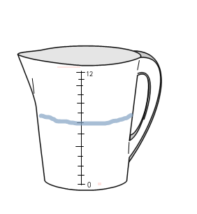 | 6 litres
What is one quarter of twelve litres? ¼ of 12 litres  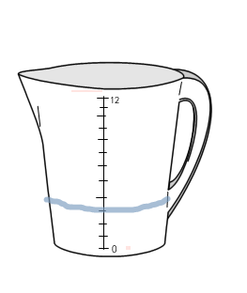 | 3 litres

What is one third of twelve litres? 1/3 of 12 litres  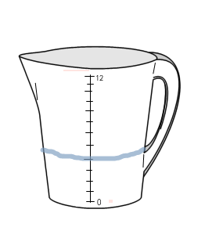 | 4 litres
What is one sixth of twelve litres? 1/6 of 12 litres  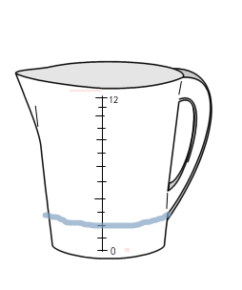 | 2 litres

What is half of ten litres? ½ of 10 litres  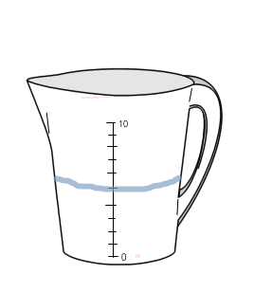 | 5 litres
What is one fifth of ten litres? 1/5 of 10 litres  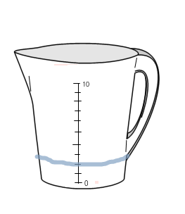 | 2 litres

What is half of twenty litres? ½ of 20 litres  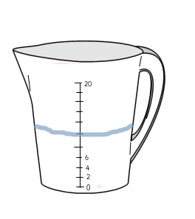 | 10 litres
What is one quarter of four litres? ¼ of 4 litres  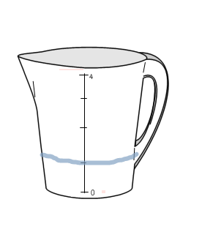 | 1 litre

What is one third of twenty-one litres? 1/3 of 21 litres  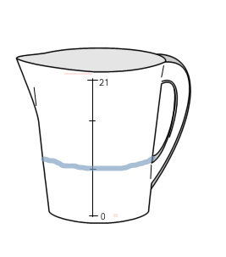 | 7 litres
What is one fifth of one hundred litres? 1/5 of 100 litres  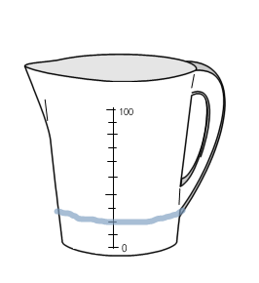 | 20 litres

What is half of sixteen litres? ½ of 16 litres  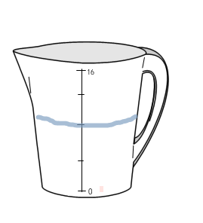 | 8 litres
What is half of eighteen litres? ½ of 18 litres  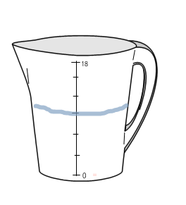 | 9 litres

