TRIANGLES WORD PROBLEMS

Work out how much each person spends?
1. David buys a wheelbarrow and a spade.
2. Harriet buys a ton of gravel and an apple tree.
3. Bobby buys a bench and a shed.
4. Nathan buys a bench and an apple tree.
5. Holly buys a wheelbarrow and a shed
Work out how much each item costs in the sale.
6. Wheelbarrow – SAVE £21.43
7. Spade – SAVE £28.16
8. Gravel – SAVE £69.67
9. Apple tree – SAVE £161.25
10. Bench – SAVE £159.29
11. Shed – SAVE £396.42

TRIANGLES WORD PROBLEMS

Work out how much each person spends?
1. David buys a wheelbarrow and a spade.
2. Harriet buys a ton of gravel and an apple tree.
3. Bobby buys a bench and a shed.
4. Nathan buys a bench and an apple tree.
5. Holly buys a wheelbarrow and a shed
Work out how much each item costs in the sale.
6. Wheelbarrow – SAVE £21.43
7. Spade – SAVE £28.16
8. Gravel – SAVE £69.67
9. Apple tree – SAVE £161.25
10. Bench – SAVE £159.29
11. Shed – SAVE £396.42

TRIANGLES WORD PROBLEMS

Work out how much each person spends?
1. David buys a wheelbarrow and a spade.
2. Harriet buys a ton of gravel and an apple tree.
3. Bobby buys a bench and a shed.
4. Nathan buys a bench and an apple tree.
5. Holly buys a wheelbarrow and a shed
Work out how much each item costs in the sale.
6. Wheelbarrow – SAVE £21.43
7. Spade – SAVE £28.16
8. Gravel – SAVE £69.67
9. Apple tree – SAVE £161.25
10. Bench – SAVE £159.29
11. Shed – SAVE £396.42

TRIANGLES WORD PROBLEMS

Work out how much each person spends?
1. David buys a wheelbarrow and a spade.
2. Harriet buys a ton of gravel and an apple tree.
3. Bobby buys a bench and a shed.
4. Nathan buys a bench and an apple tree.
5. Holly buys a wheelbarrow and a shed
Work out how much each item costs in the sale.
6. Wheelbarrow – SAVE £21.43
7. Spade – SAVE £28.16
8. Gravel – SAVE £69.67
9. Apple tree – SAVE £161.25
10. Bench – SAVE £159.29
11. Shed – SAVE £396.42

TRIANGLES WORD PROBLEMS

Work out how much each person spends?
1. David buys a wheelbarrow and a spade.
2. Harriet buys a ton of gravel and an apple tree.
3. Bobby buys a bench and a shed.
4. Nathan buys a bench and an apple tree.
5. Holly buys a wheelbarrow and a shed
Work out how much each item costs in the sale.
6. Wheelbarrow – SAVE £21.43
7. Spade – SAVE £28.16
8. Gravel – SAVE £69.67
9. Apple tree – SAVE £161.25
10. Bench – SAVE £159.29
11. Shed – SAVE £396.42

TRIANGLES WORD PROBLEMS

Work out how much each person spends?
1. David buys a wheelbarrow and a spade.
2. Harriet buys a ton of gravel and an apple tree.
3. Bobby buys a bench and a shed.
4. Nathan buys a bench and an apple tree.
5. Holly buys a wheelbarrow and a shed
Work out how much each item costs in the sale.
6. Wheelbarrow – SAVE £21.43
7. Spade – SAVE £28.16
8. Gravel – SAVE £69.67
9. Apple tree – SAVE £161.25
10. Bench – SAVE £159.29
11. Shed – SAVE £396.42

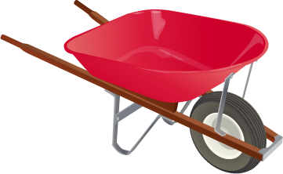 | £132.56
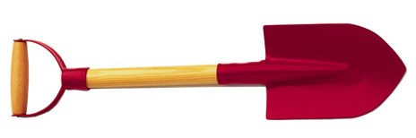 | £84.32
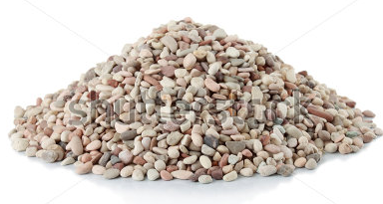 | £147.93
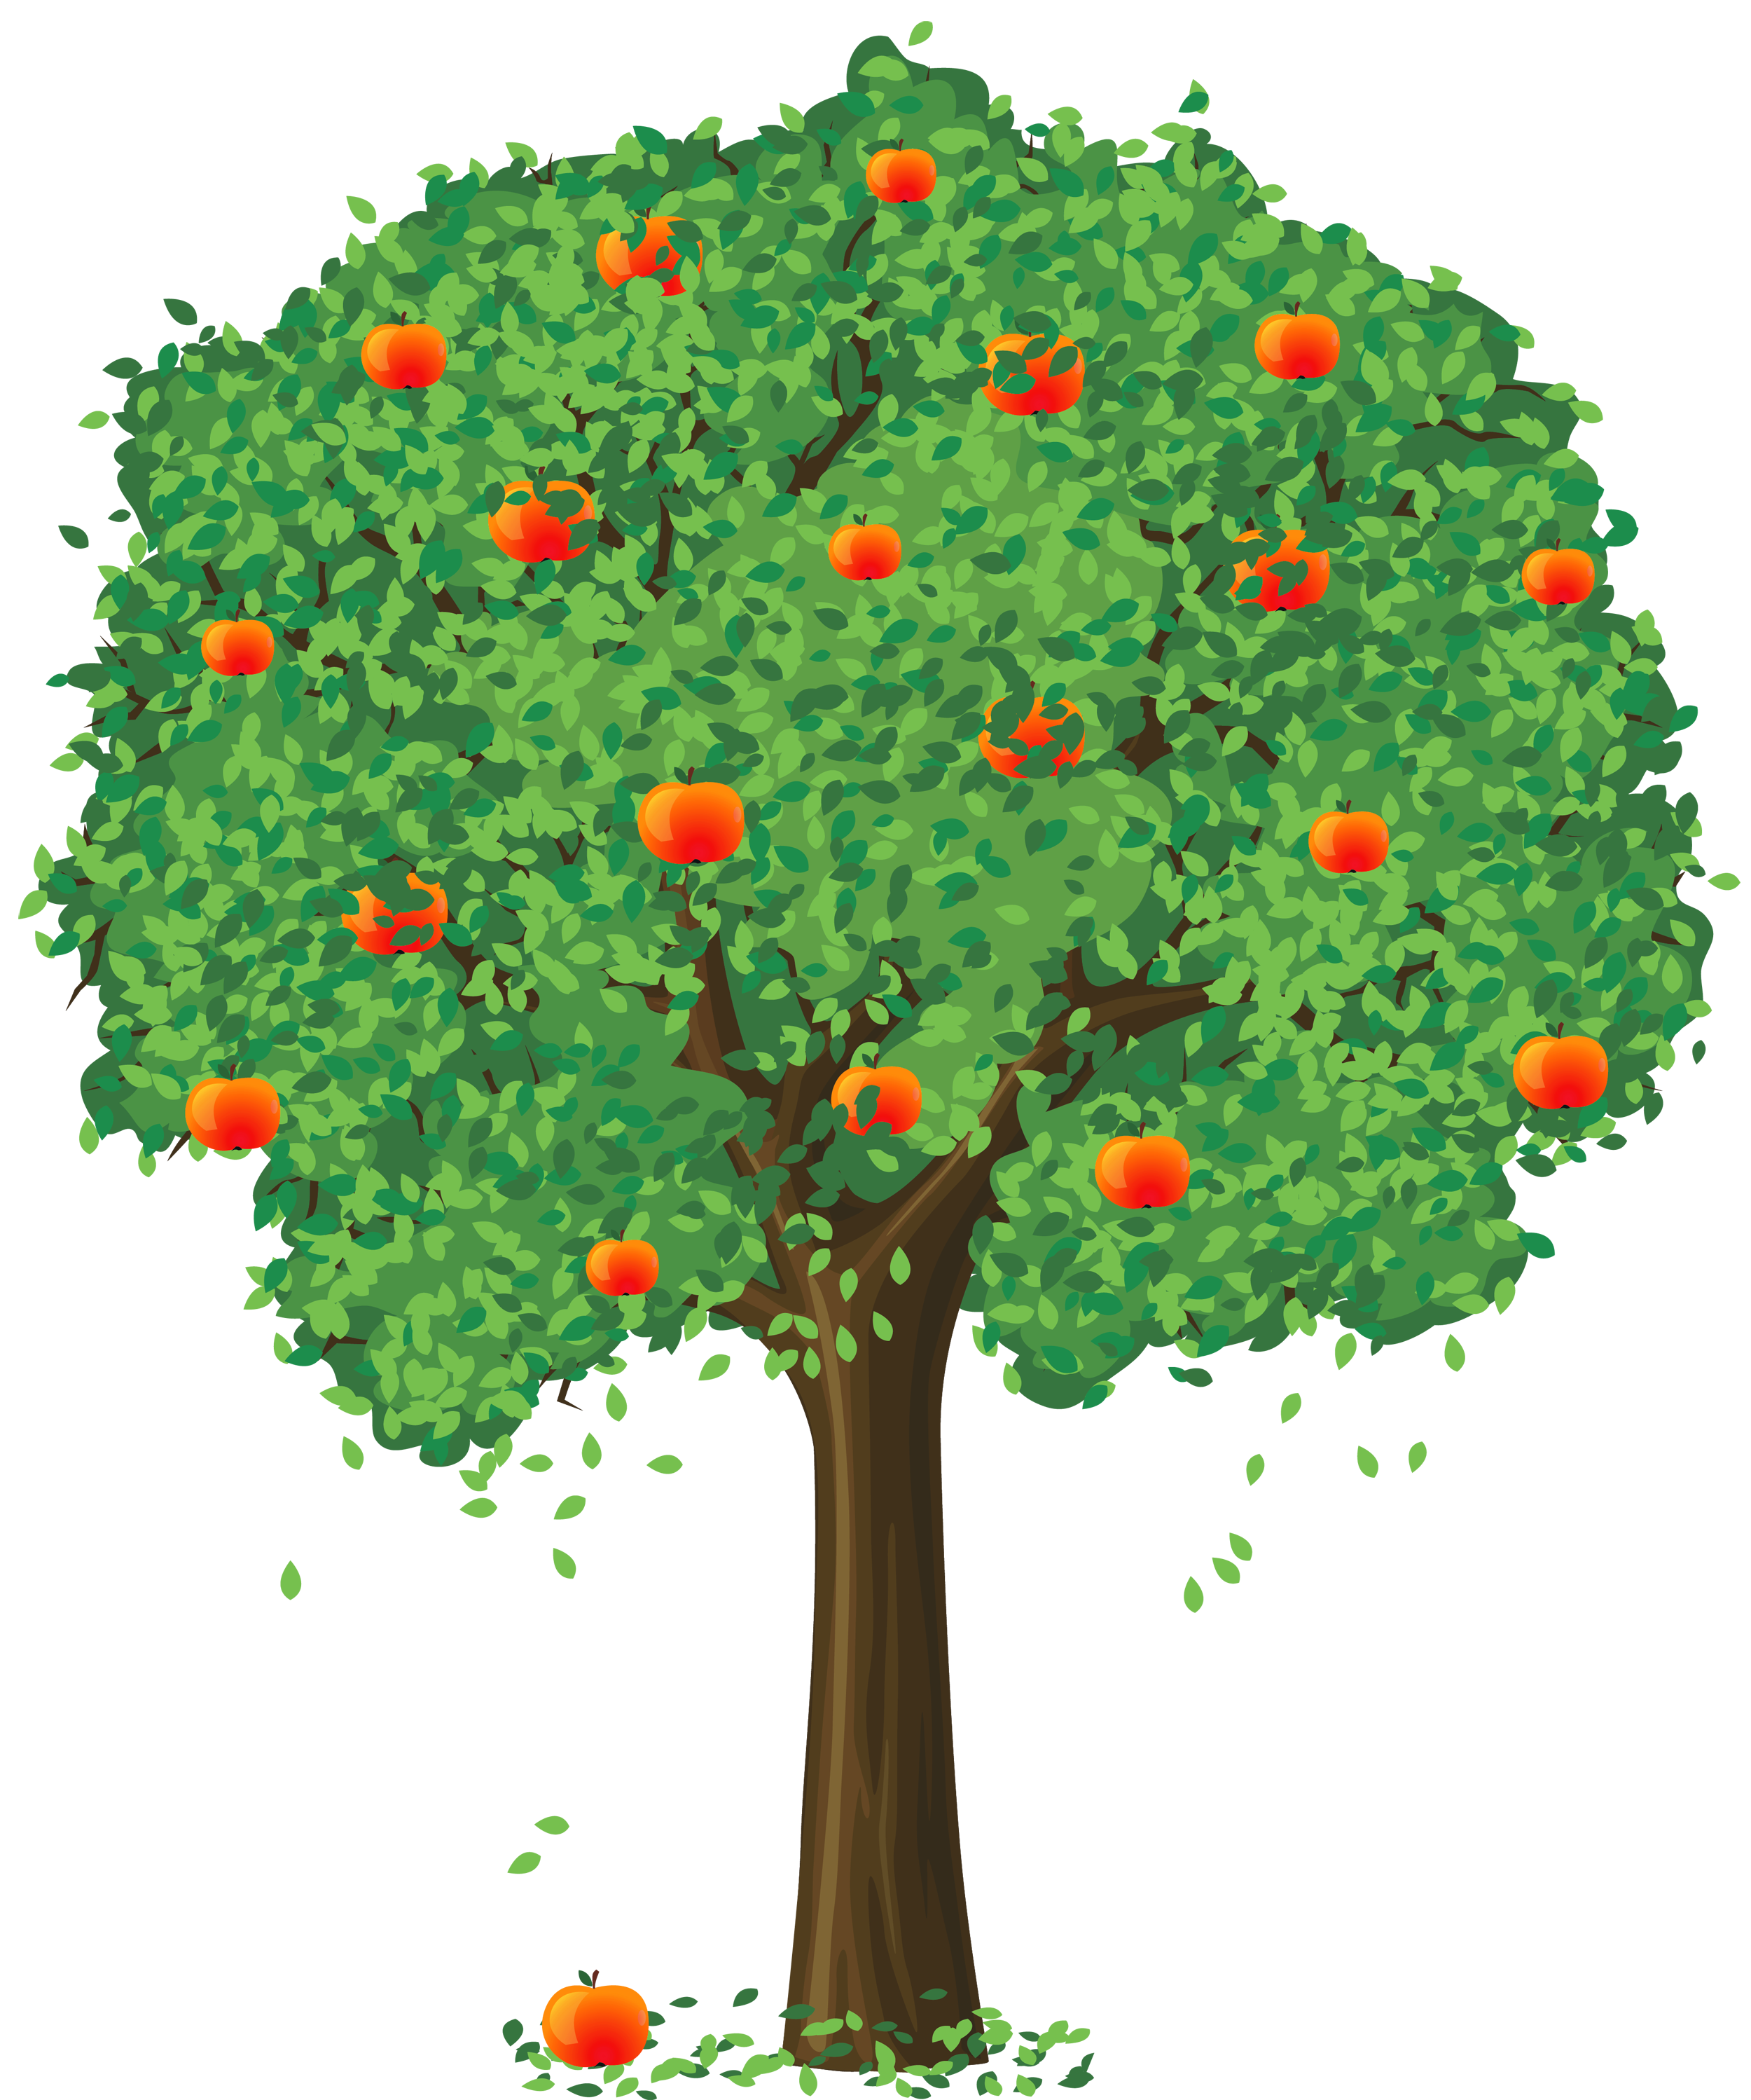 | £259.74
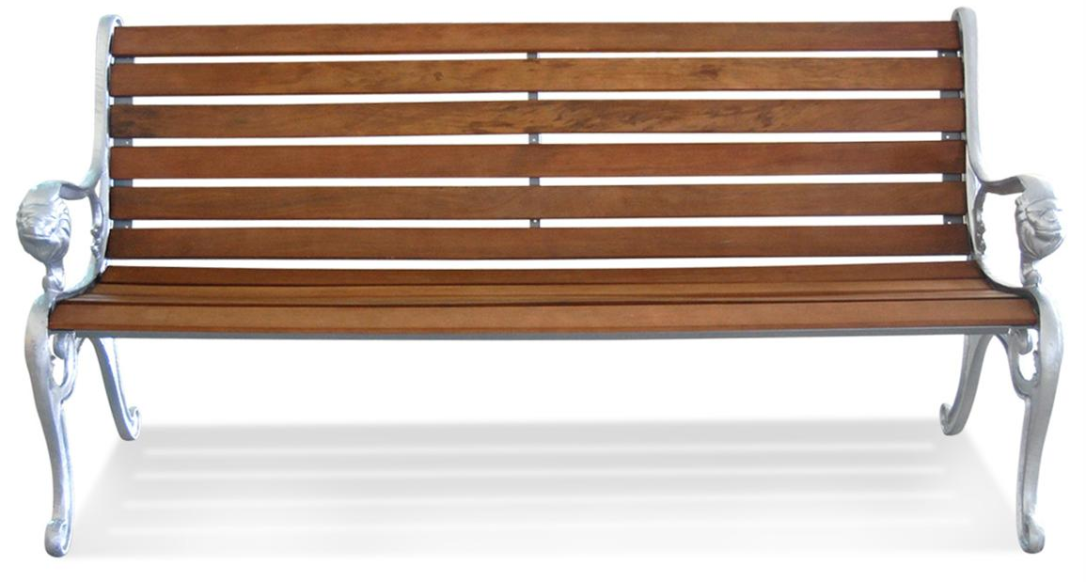 | £316.85
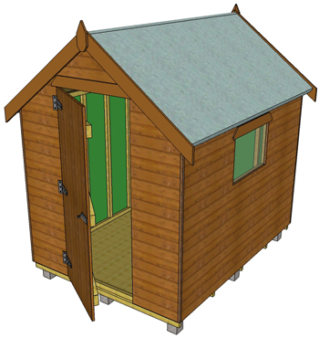 | £672.17

£132.56
£84.32
£147.93
£259.74
£316.85
£672.17

