Name: ____________________________________________________ Date: ____________________________-

LO: I can work out what something costs when it is half price

8p  half price | 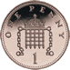 | How much is half price?

6p  half price |  | How much is half price?

10p  half price |  | How much is half price?
4p  half price |  | How much is half price?

2p  half price |  | How much is half price?

8p  half price |  | How much is half price?

  10p  half price |  | How much is half price?
12p  half price |  | How much is half price?

14p  half price |  | How much is half price?

20p  half price | 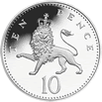 | How much is half price?

Name: ____________________________________________________ Date: ____________________________-

LO: I can work out what something costs when it is half price

8p  half price |  | How much is half price?

6p  half price |  | How much is half price?

10p  half price |  | How much is half price?
4p  half price |  | How much is half price?

2p  half price |  | How much is half price?

18p  half price |  | How much is half price?

16p  half price |  | How much is half price?
12p  half price |  | How much is half price?

14p  half price |  | How much is half price?

20p  half price |  | How much is half price?

Name: ____________________________________________________ Date: ____________________________-

LO: I can work out what something costs when it is half price

28p  half price |  | How much is half price?

46p  half price | 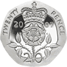 | How much is half price?

£1  half price |  | How much is half price?
42p  half price |  | How much is half price?

£4.02p  half price | 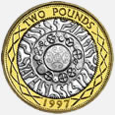 | How much is half price?

68p  half price |  | How much is half price?

£2.06p  half price |  | How much is half price?
£1.12p  half price |  | How much is half price?

£3.14p  half price |  | How much is half price?

£5. 20p  half price |  | How much is half price?

