

Instructions:

- Cut around the outside of both black squares – but not down the middle – this is to be folded to make the case of your compass.
- Label the dial. Cut it out and stick inside the compass case on the bottom. Make sure you stick N next to the fold
- Colour in the arrows on the top insert (the one that says ‘property of…) and label them clockwise and anticlockwise
- Make a pointer.
- Using a split pin attach the pointer to the middle of the dial (ask your teacher to help).
- Cross out Jack Sparrow’s name as this compass now belongs to you! Write your name on the line.
- Now you can play some compass maths games !!!! Arrrrrgh !!!!

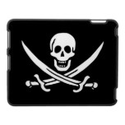
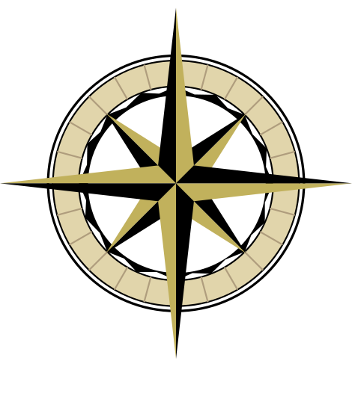
Property of
Captain Jack Sparrow

____________

360°/ 0°

270° 90°

180°

Name…………………………………………………………..……… Date ………………………………….

Jack Sparrow’s Compass Quiz 1

Using Jack Sparrow’s compass draw the arrow position after you have made the turn and write the compass label.

Start your arrow here: | Turn: | Final position:
N | Quarter turn anticlockwise
N | Quarter turn clockwise
S | Half turn clockwise
E | Half turn anticlockwise
S | Half turn anticlockwise
W | Full turn clockwise
N | Half turn clockwise
S | Quarter turn anticlockwise
W | Quarter turn clockwise
E | Full turn anticlockwise
N | Quarter turn anticlockwise
S | Quarter turn clockwise
Name…………………………………………………………..……… Date ………………………………….

Jack Sparrow’s Compass Quiz 2

Using Jack Sparrow’s compass draw the arrow position after you have made the turn and write the compass label.

Start your arrow here: | Turn: | Final position:
NW | Quarter turn anticlockwise
NE | Quarter turn clockwise
SE | Half turn clockwise
SE | Half turn anticlockwise
SW | Half turn anticlockwise
NW | Full turn clockwise
NE | Half turn clockwise
SE | Quarter turn anticlockwise
SW | Quarter turn clockwise
NE | Full turn anticlockwise
NE | Quarter turn anticlockwise
SE | Quarter turn clockwise
Name…………………………………………………………..……… Date ………………………………….

Jack Sparrow’s Compass Quiz 3

Using Jack Sparrow’s compass draw the arrow position after you have made the turn and write the compass label.

Start your arrow here: | Turn: | Final position:
N | 90 degree turn anticlockwise
N | 90 degree turn clockwise
S | 180 degree turn clockwise
E | 180 degree turn anticlockwise
S | 180 degree turn anticlockwise
W | 360 degree turn clockwise
N | 180 degree turn clockwise
S | 90 degree turn anticlockwise
W | 90 degree turn clockwise
E | 360 degree turn anticlockwise
N | 90 degree turn anticlockwise
S | 90 degree turn clockwise
Name…………………………………………………………..……… Date ………………………………….

Jack Sparrow’s Compass Quiz 4

Using Jack Sparrow’s compass draw the arrow position after you have made the turn and write the compass label.

Start your arrow here: | Turn: | Final position:
NW | 90 degree turn anticlockwise
NE | 90 degree turn clockwise
SE | 180 degree turn clockwise
SE | 180 degree turn anticlockwise
SW | 180 degree turn anticlockwise
NW | 360 degree turn clockwise
NE | 180 degree turn clockwise
SE | 90 degree turn anticlockwise
SW | 90 degree turn clockwise
SE | 360 degree turn anticlockwise
NE | 90 degree turn anticlockwise
SE | 90 degree turn clockwise
Name…………………………………………………………..……… Date ………………………………….

Jack Sparrow’s Compass Quiz 5

Using Jack Sparrow’s compass draw the arrow position after you have made the turn and write the compass label.

Start your arrow here: | Turn: | Final position:
N | 270 degree turn anticlockwise
N | 90 degree turn clockwise
S | 360 degree turn clockwise
E | 270 degree turn anticlockwise
S | 90 degree turn anticlockwise
W | Three quarter turn clockwise
N | 270 degree turn clockwise
S | Three quarter turn anticlockwise
W | 180 degree turn clockwise
E | 270 degree turn anticlockwise
N | 360 degree turn anticlockwise
S | Two quarters turn clockwise

