Sally is shopping with these coins in her purse.
Which things could she pay for exactly?

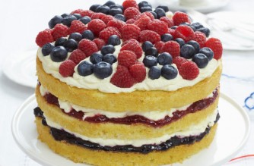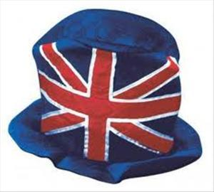
49p 45p 14p
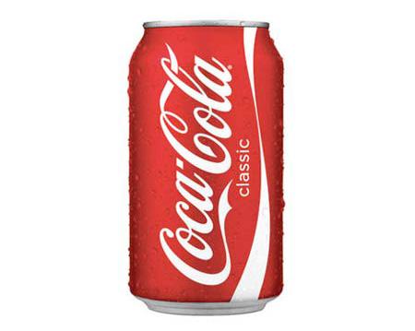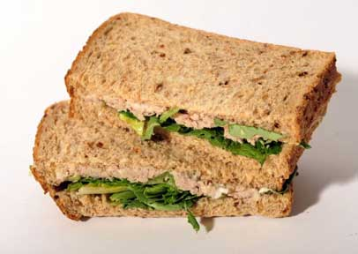
52p 3p

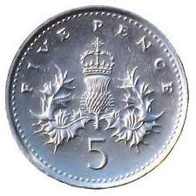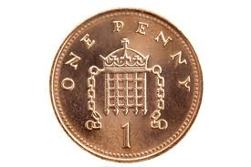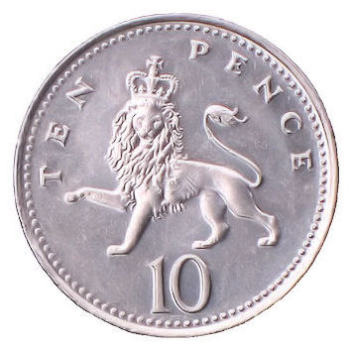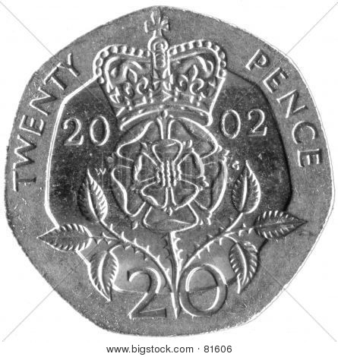

Jim bought a balloon for the Jubilee.
He gave the shop keeper six coins to pay for it.

What prices could Jim have paid for the balloon?

Jim bought a balloon for the Jubilee.
He gave the shop keeper six coins to pay for it.

What prices could Jim have paid for the balloon?
Adam buys a Jubilee Stamp.
He pays with 3 coins.

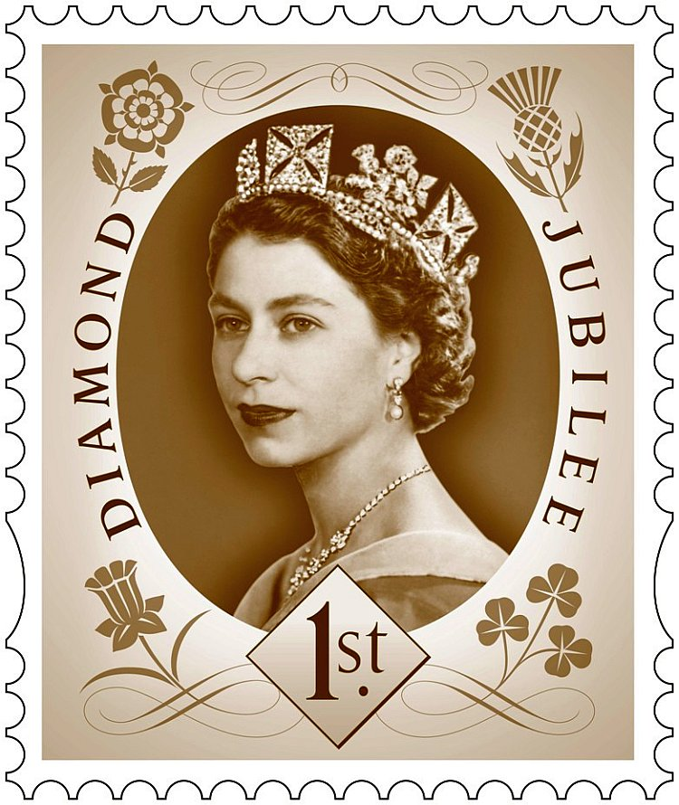
How much could the stamp cost?

Adam buys a Jubilee Stamp.
He pays with 3 coins.

How much could the stamp cost?

Anna buys a Jubilee Hello Kitty toy.
She pays with 4 coins.

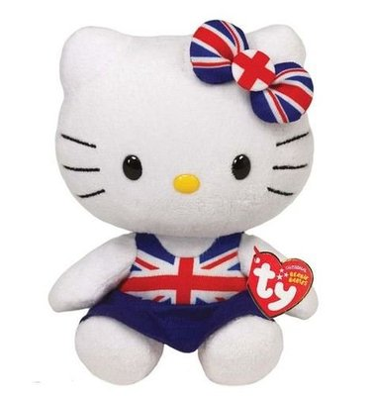
It costs more than 10p.
How much could the toy cost?

Anna buys a Jubilee Hello Kitty toy.
She pays with 4 coins.

It costs more than 10p.
How much could the toy cost?

Hannah bought a Jubilee Teddy using only silver coins.
It cost her 45p
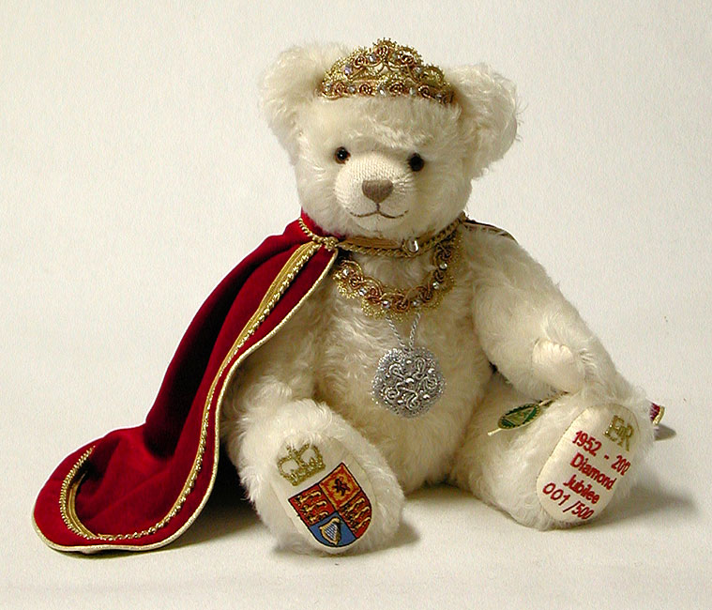
There are 9 different ways to pay 45p exactly.
Find as many as you can!

Hannah bought a Jubilee Teddy using only silver coins.
It cost her 45p
There are 9 different ways to pay 45p exactly.
Find as many as you can!

