Goldilocks and the Three Bears
Draw the characters from the story and make sure that they are the correct height!

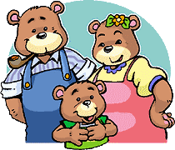

Goldilocks = 18cm tall
Daddy Bear = 30cm tall
Mummy Bear = 25cm tall
Baby Bear = 7cm tall

Goldilocks and the Three Bears
Draw the characters from the story and make sure that they are the correct height!

Goldilocks = 18cm tall
Daddy Bear = 30cm tall
Mummy Bear = 25cm tall
Baby Bear = 7cm tall

