Mad Multiples!

Work out the answers to the multiplication sums below:

Each Ant has 6 legs, work out how many legs there are in total and write the multiplication sum by the side.

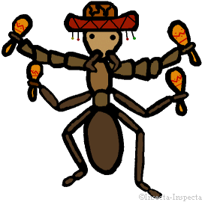
1.

2.

3.

4.

5.

6.

7.

8.

9.

10.

11.

12.

