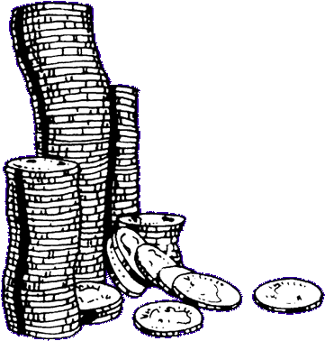
Making Money!
Learning objective: To be able to work out an amount using smaller coins.
How many ways can you make 10p?
Use 2 coins:
___________________________________________
Use 5 coins:
___________________________________________
Use 6 coins:
___________________________________________
How many times can you make 15p?
Use 3 coins:
___________________________________________
Use 4 coins:
___________________________________________
Use 5 coins:
___________________________________________
Use 8 coins:
___________________________________________

