This week the class is going to be exploring maths whilst on a trip to the Maldives!

On this trip you will be practising your maths skills and applying them to our trip to the Maldives!

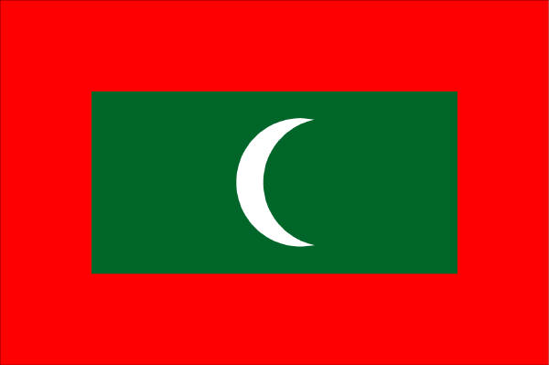
During this trip we will be learning to:
- Recall all addition and subtraction facts for each number to 20
- Use number operations to solve money problems
- Convert units of money (pounds to pence and pence to pounds)
- Use number operations to solve time problems
- Read the time from an analogue clock and display time in digital form
- Write the time or draw hands on an analogue clock

Welcome to the Year 3 Trip to the Maldives!

(Note to teachers: insert picture(s) of the Maldives here)

We are lucky to be going to such an amazing place, but first of all we need to work out when we are going to go.

The next sheet will help us understand how to read a calendar, so we can decide when we are going to the Maldives.
So, we have decided to go to the Maldives during half-term. We will leave on Monday _______ February and return 6 days later on ______________ 27th February.

Our flight leaves at half past ten in the morning. Can you write that in digital form:

_______________________

If we need to be at the airport two hours before the flight leaves, what time do we need to get there?

_______________________

We are going to use a coach to get to the airport because there are so many of us. In Year 3 there are 30 children and two teachers. How many people will be travelling altogether? ________________

On the coach there are four seats in each row. How many rows will we need for the whole group to be able to sit down on the journey? (SHOW YOUR WORKING)

____________________________

Once we arrive at the airport, we have to pay the coach driver. Each person has to pay £2.55. How much is this if we were counting it in pence?

_________________________

The driver then tells us that we have to pay 127 pence extra per person because we left rubbish on the bus!
Can you write this in pounds and pence? (£)

________________________________

I think next time we’ll remember to leave the coach nice and tidy, and keep our rubbish in our bags.
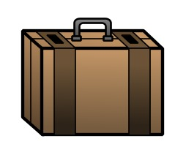

Once we got off the coach, we collected our suitcases. Each boy had two suitcases and each teacher had three suitcases. How many suitcases were there in total?

______________________________________

When we get into the airport there are analogue clocks everywhere. Our flight is at half past ten, and we needed to be there two hours early so we need to check the clocks to see if we are on time.

Draw the time of our flight on this analogue clock:

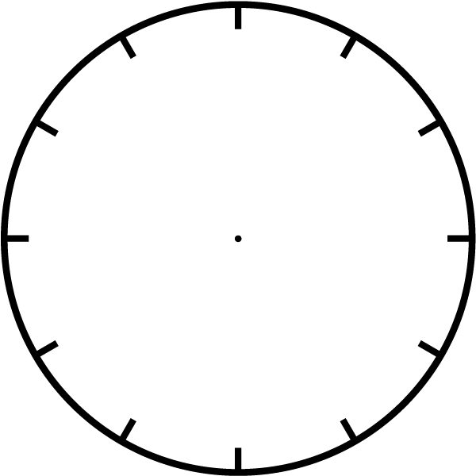

On the aeroplane there are 124 other passengers. Including the group of children and teachers from our class, how many people are on the aeroplane altogether? (SHOW YOUR WORKING)

________________________

On the aeroplane each row has six chairs. How many rows are needed in total for all the passengers to sit on the aeroplane? (SHOW YOUR WORKING)

_________________________

Enjoy your flight!

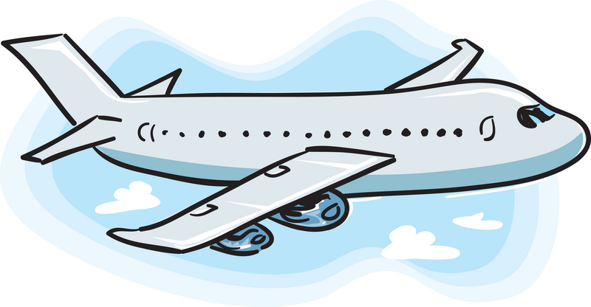

During the flight we all got hungry and decided to read the food menu.

Can you change the prices if the food from pence to pounds?
Food: | Cost in Pence | Cost in Pounds (£)
Peanuts | 102
Crisps | 70
Ham Sandwich | 234
Ginger Biscuits | 175
Popcorn | 500
Pizza | 899
Chocolate Bar | 99
BBQ Ribs | 1125
Napkin | 5

The drinks menu has been done the other way round. The prices are in pounds. Can you change the price so that it is shown in pence?

Drinks | Cost in Pounds (£) | Cost in Pence
Water | £0.99
Coca Cola | £2.25
Orange Juice | £0.87
Lemonade | £2.10
Fruit Smoothie | £7.35
Bottle of Wine | £15.75
Bottle of Champagne | £45.99
Tonic Water | £2.82
Sports Energy Drink | £3.45

How much would it cost if bought the following:

- A lemonade and a sports energy drink?

_______________

- Popcorn and an orange juice?

_______________

- A pizza, a tonic water and a napkin?

_______________

- A fruit smoothie, a chocolate bar and a packet of peanuts?

________________

The flight left at half past ten and took six and a half hours.

What was the time when we arrived?

_________________________

The Maldives is 5 hours ahead of the GMT which means they are five hours ahead of our local time.
What is the local time when we arrive in the Maldives?

_________________________

Can you draw this time on the analogue clock?

This next sheet asks us to find out the time difference between two clocks which will help when we are travelling between countries with a time difference!

The drive from the airport to the hotel took 55 minutes. What time did we arrive at the hotel?
_______:________

When we arrived at the hotel, we had to register at reception. It took 3 minutes to register each person in our group. How long did it take for the 32 people in our group to register?

_____________ minutes

The teachers were staying in their own room but the 30 children were staying in lodges. Each lodge had 5 beds. How many lodges were needed for all of the children?

___________________ lodges

The week was great fun with lots of activities!

We spent 2 hours fishing, 1 and a half hours windsurfing and 45 minutes snorkelling in the morning. We started at 8:45 am, so what time did we finish all of the activities for lunch?

_______:_________

Tuesday:
We finished lunch at 1:45 pm and then spent 3o minutes relaxing on the beach, followed by 45 minutes snorkelling and then 2 hours sailing. What time did we finish the afternoon activities?

________:________

Wednesday:
We began windsurfing at 9:30 am and finished it at 11:55 am. How long did we spend windsurfing?

_____________________________________
Thursday:
We out at 2:30pm after lunch and returned to the lodges at 5:00pm. We spent half the time walking and half the time swimming. How long did we spend swimming that afternoon?

______________________________________

Friday:
In the evening we had a party which started at 7:30pm. It took us 35 minutes to shower, change and get ready. At what time did we start getting ready so we would not be late for the party?



For the party on the Friday night the teachers bought each boy an afro wig and some funky trousers. One afro wig cost £2.50 and one pair of funky trousers cost £8.85. How much did the cost together?

___________________________

If the teachers paid with a £20 note, how much change would they get when he bought one afro wig and one pair of funky trousers?

___________________________

The teachers also bought the boys some cool glasses. Each pair of glasses cost £2.50. How much would it cost for the children in each lodge to have a pair of cool glasses? (Remember there are 5 children in each lodge!)

____________________________
Snorkelling Bonds!!
Whilst snorkelling, the children challenged themselves to count how many things they can see under the water. Can you count how many sea creatures the children saw?

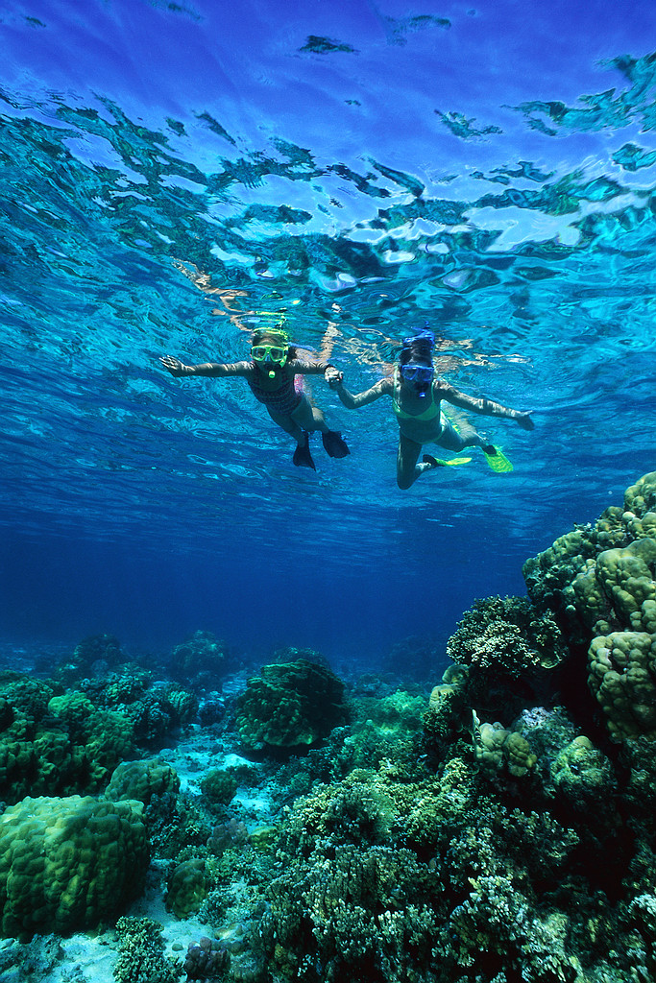

5 tunas + 3 turtles = __________ sea creatures
8 barracuda + 14 tiger fish = __________ sea creatures
7 corals + 2 lobsters = __________ sea creatures
5 clams + 10 prawns = __________ sea creatures
13 stingrays + 6 turtles = __________ sea creatures
19 swordfish + 11 dolphins = __________ sea creatures
14 kingfish+ 14 manta rays = __________ sea creatures
6 turtles + 5 lobsters = __________ sea creatures
12 marlin + 28 king mackerel = __________ sea creatures
3 lemon sharks + 39 starfish = __________ sea creatures
The flight back to England takes off at 11:25am but we need to be there 2 hours before takeoff. Can you show these times on the analogue clocks below?

Arrival at the airport
Takeoff

We hope you enjoyed your trip to the Maldives, had fun and learnt or practised your maths skills! Well done!

