We measure Length in:
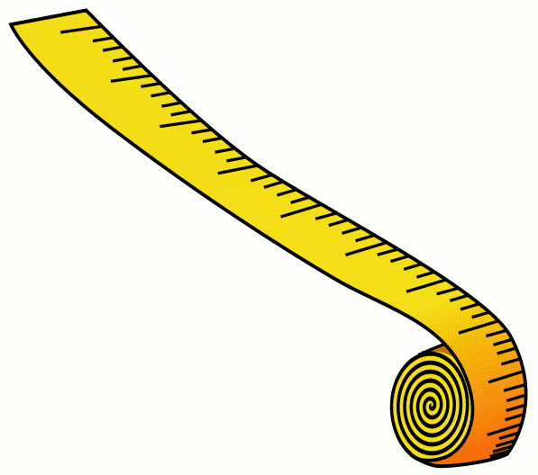
mm cm m km
millimetres centimetres metres kilometres
10mm = 1cm 100cm = 1m 1000m = 1km

J.Phillips 07
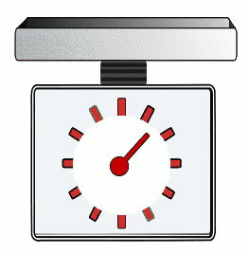
We measure Mass (weight)) in:
g kg
grams kilograms

1000g = 1 kg
J.Phillips 07
We measure Capacity in:
ml cl l
millilitres centilitres litres
10ml = 1 cl 100cl = 1l 1000ml = 1l

J.Phillips 07
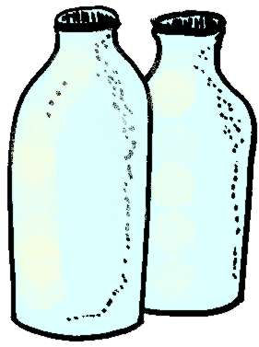
There are
568ml in 1 pint
(about 500ml =1 pint so ½ litre = approx 1 pint!)
J. Phillips 2007

