Jenny needs to take a 5ml spoonful of medicine twice a day for 7 days.  Her medicine bottle has 40mls in it.  She has already taken the medicine for 2 whole days. | Matthew is making an orange drink from concentrate. He wants to make 2 litres. He needs to use 100ml of concentrate for every 500ml of juice.
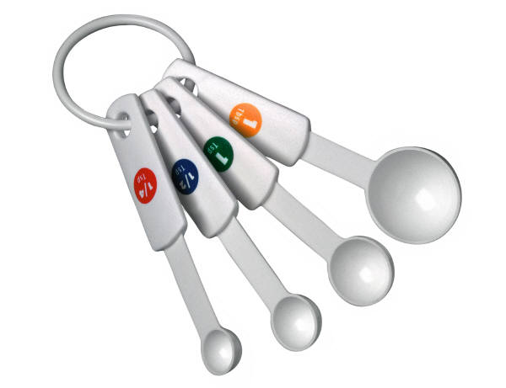  Adela is using a recipe that tells her to use three tablespoons. She only has a teaspoon. A tablespoon holds 15ml, and a teaspoon holds 5ml. | Grandma used to give her children cod liver oil. She had two children, and gave them both a teaspoon (5ml) a day. She could only go shopping once a week. In the shop one bottle of cod liver oil held 50ml and the other one held 100ml.
Mum drinks two 150 ml cups of coffee every day. Her friend Julie comes to visit on a Wednesday and they both have another cup of coffee. | To make strawberry ice-cream Jonas needs 300ml of cream for every punnet of strawberries. He has 2½ punnets of strawberries.
Shreeti wants to make cherry jam. 500g of cherries will make 300ml of jam. Her jars have a capacity of 250mls. She has She has 2½kg of cherries. | Kristan wants to make pasta for a pasta salad. Each packet holds 500g of pasta, which needs to be cooked in a litre of water. He only needs to use 200g of pasta for the salad.
Grandad is putting oil in his car. He only wants to use half of his oil can. His oil can holds 5 litres. | Sam wants to buy Mum some perfume for her birthday. One kind is 100mls and costs £15. The other one is 60mls and costs £12.
To make a 6 inch Christmas cake Simon needs 3 eggs and 3 tablespoons of brandy. Simon wants to make an 8 inch Christmas cake. | To make pancakes a recipe uses milk, two eggs and flour. Ellie needs to add 150mls of egg and milk mixture to the flour. She uses two eggs which come up to the 60ml mark on her measuring jug.
These are practical maths situations where there is no question asked but the children are given it to think about which function (add, take away, divide, multiply) they would use - even if they are not able to get the answer.

You could get students to come up with a question that you could ask about each of the facts and higher ability children could then go on to find the answers.

