Measure these pencils then cut them out and order them.
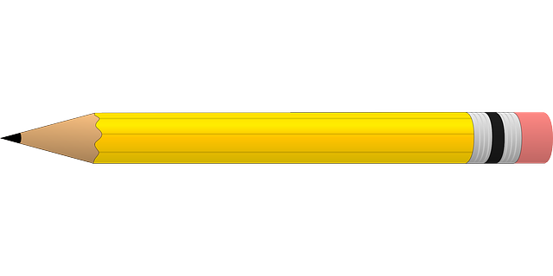
Challenge: Which ones would show above our pencil pots?

