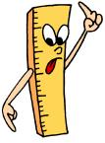
Name Date

LOFT: to measure accurately using centimetres (cm)

- Use a ruler to measure these pictures of objects.

width = cm

height = cm

width = cm

height = cm

length cm

height cm

height cm

width cm

length = cm

height = cm

- Draw some pictures of objects of your own and write their measurements.

