Measuring Weight
Learning objective: To be able to weigh using non-standard objects.
Using the table below find out how much the objects weigh using the units on your tables.
Unit | Weight/How many?

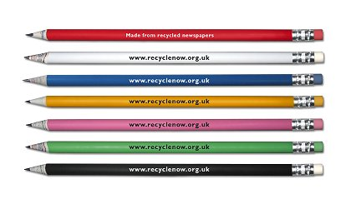
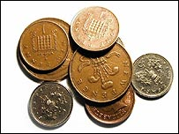
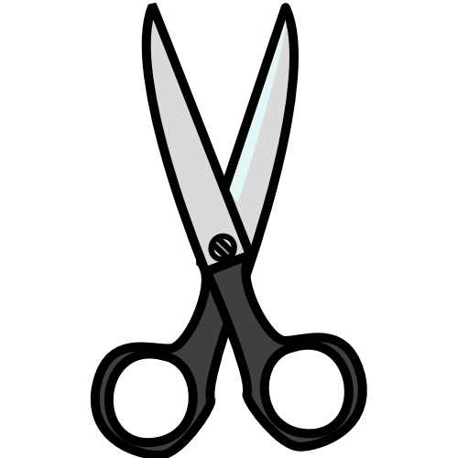

Talk to your teacher about what you have found!
Measuring Weight
Learning objective: To be able to estimate and weigh using non-standard units.
Using the table below:
FIRST: estimate how many of each unit your object is going to weigh.
THEN: weigh how much the objects weigh using each unit.
Unit | Estimation | Weight/How many?
Cubes
Pencils
Coins
Scissors

FINALLY: answer the questions on the back of your sheet.
Measuring Weight
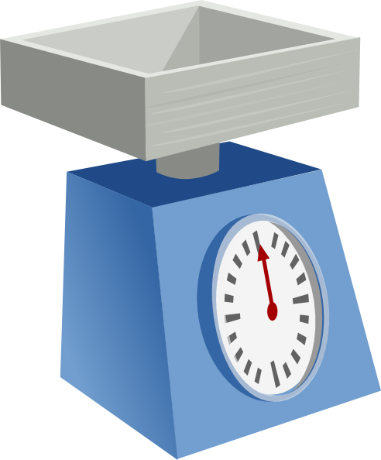
Learning objective: To be able to weigh using standard units of measurement.
FIRST: answer the questions
THEN: weigh your objects using the scales
FINALLY: record the weight in the table
Object | Weight (grams)
Cup 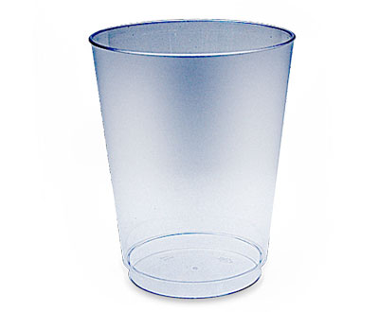
Reading book 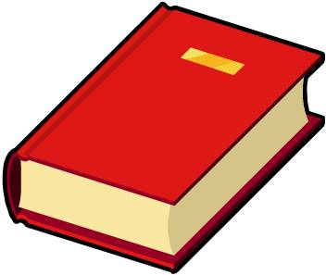
Scissors 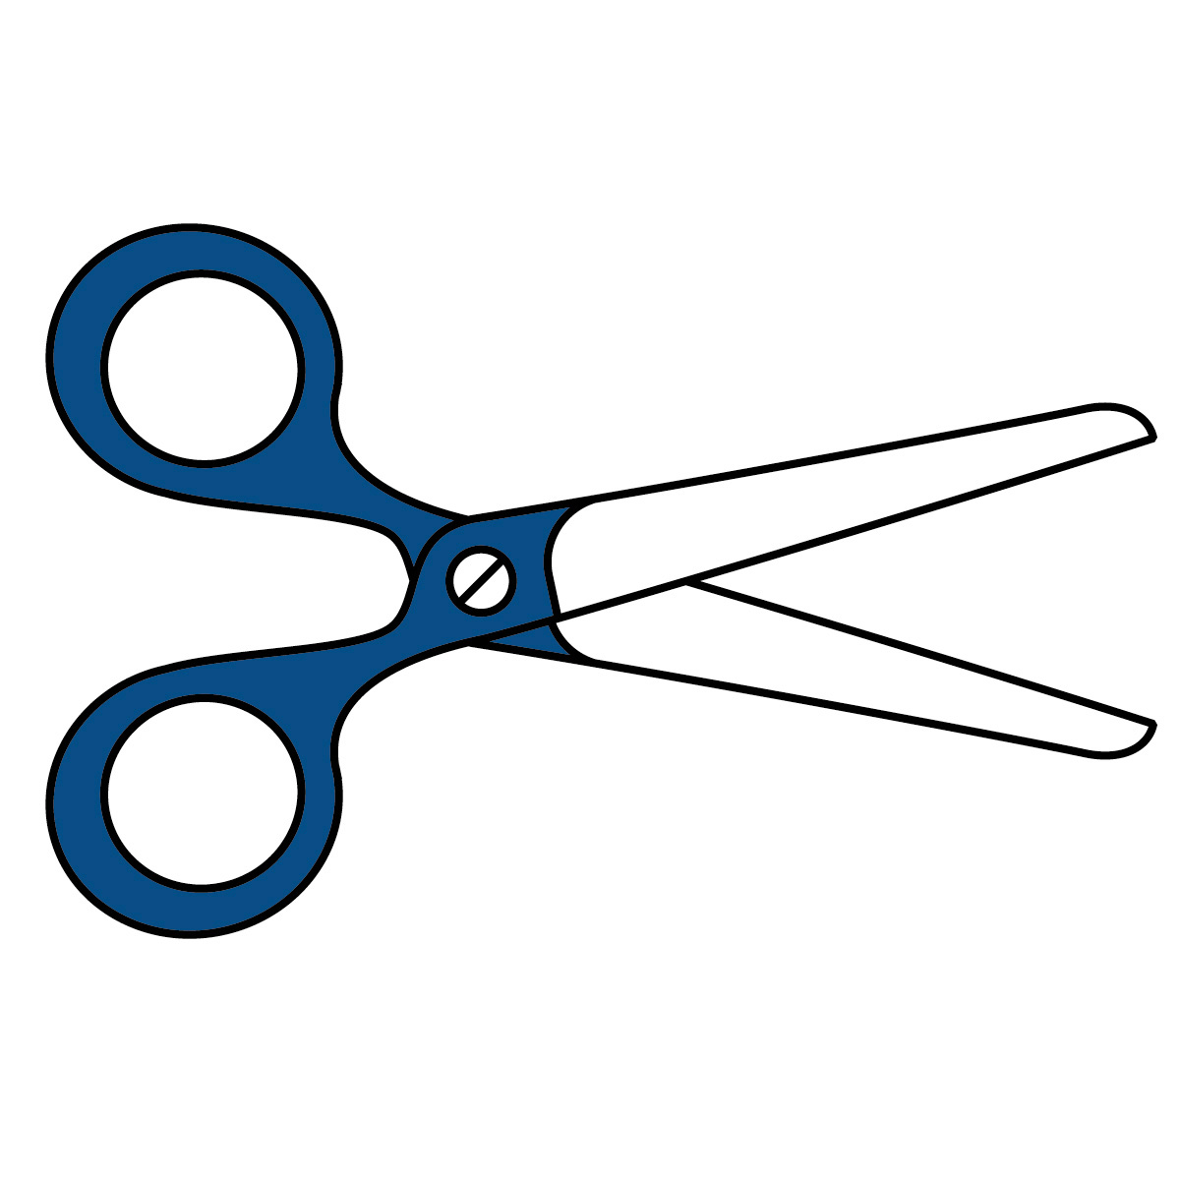
Glue stick 
Which object do you think will be the heaviest? _________________________
Which object do you think will be the lightest? _________________________
Measuring Weight
Learning objective: To be able to estimate using standard units of measurement.
FIRST: answer the questions
THEN: weigh your objects using the scales
FINALLY: record the weight in the table
Which object do you think will weigh the most? _________________________
Object | Weight (grams)
Cup
Reading book
Scissors
Glue stick
10 Cubes
Which object do you think will weigh the least? _________________________

