A can of coke costs 5p and orange juice costs 10p.
How much would it cost to buy a can of cola and some orange juice?
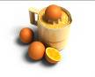

Tom’s mum sends him to buy a glass of milk for 2p, some orange juice for 5p and a can of cola for 10p.
How much does he spend?

I buy an apple for 1p, an orange for 5p, and a drink for 10p. How much do I spend in total?

Oranges cost 5p a kilo, apples 10p. I buy 1 kilo of each. How much do I spend?
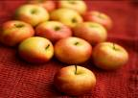

I buy 3 bananas for 5p each. How much do I spend altogether?


A pen costs 18p a pad 5p. How much do I spend in total?


My pencil costs 7p. I buy 4 of them. How much do I spend in total?


I buy 3 hair bands at 5p each. How much do I spend?

I buy 5 apples for 5p each. How much do I spend altogether?

I buy 7 rubbers at 5p each. How much do I spend?
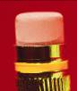

Eight pencils cost 80p. How much does each pencil cost?
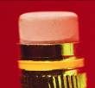

Ten sweets cost 50p. How much does each sweet cost?


I buy 7 sweets at 3p each. How much do I spend?


