
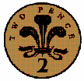


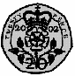
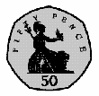
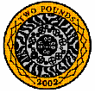
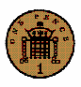
How much are these coins worth?

Draw some coins that you could use to make 30p.


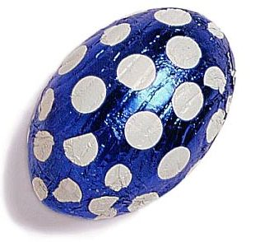

2p12p
20p
2p
5p
How much change would I get from 30p?
12p

12p + 8p = 20p + 10p =
10p + 9p = 16p + 6p =
16p + 4p = 28p + 9p =

How much are these coins worth?

Draw some coins that you could use to make 20p.

+
=

+
=

+
+
=

How much are these coins worth?

Draw some coins that you could use to make 50p.

2p12p
20p
2p
5p
How much change would I get from 50p?
12p

12p + 8p = 31p + 10p =
22p + 9p = 40p + 6p =
16p + 20p = 28p + 13p =

