Number bonds to 10

L.O: To recall addition facts to 10.

Each ladybird has 10 dots. Draw the dots on the other wing to help you work out the number bonds to 10.

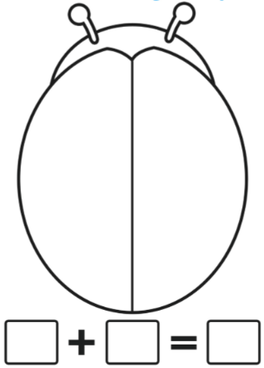
2

Number bonds to 10

L.O: To recall addition and subtraction facts to 10. (Orange)

Each ladybird has 10 dots. Draw the dots on the wings to help you work out all the possible ways to make 10.

1

What numbers could fill the boxes?

10 - =

10 - =

10 - =
10 - =

10 - =

10 - =

