Name:_____________________ Date:____________

Party Planner

We are going to use our knowledge of

Word problems
Fractions
Patterns
Partitioning
Data
Multiples

to help plan a party!



There will be ______ guests at your party

You will be celebrating

______________________________
The first thing you need to sort is the tables, as everyone will need somewhere to sit.

There are circular tables and square tables.

____ chairs fit round each circular table.

____ chairs fit round each square table.

How many circular tables will you need, remember every guest must be able to sit down? ______

How many square tables will you need, remember every guest must be able to sit down? ______

(HINT: YOU MAY HAVE TO ROUND ONE OF YOUR ANSWERS UP!)

You want the least amount of tables. What ones do you have? Circular or Square? ____________
You need to have some table cloths to cover the tables. Using _____ colours, create a different pattern for each table cloth

1)

2)

3)

Get your friends to choose which design they like best…
 | Friend 1 | Friend 2 | Friend 3 | Friend 4 | Friend 5
cloth

Which cloth is the most popular? ______
To say thank you to all of your guests you are going to buy them each a gift.

What gift would you like to buy each of them?

____________________

Your gift costs _______. How much will you spend if you buy each guest a gift? _________

You have _______ to spend. How much change will you get once you have bought all of the guests gifts? _______

How much money would you need to spend if you bought each guest _____ gifts?

What about if you were really kind and bought each guest ___ gifts? How much would that cost? _____

Your guests are really kind. They each bought you gift. ____ of your guests bought you _________. ____ of your guests bought you _________. And ____ of your guests bought you _________.

Now draw a bar chart below to show the gifts your guests bought you.

(HINT: DON’T FORGET THE TITLES)

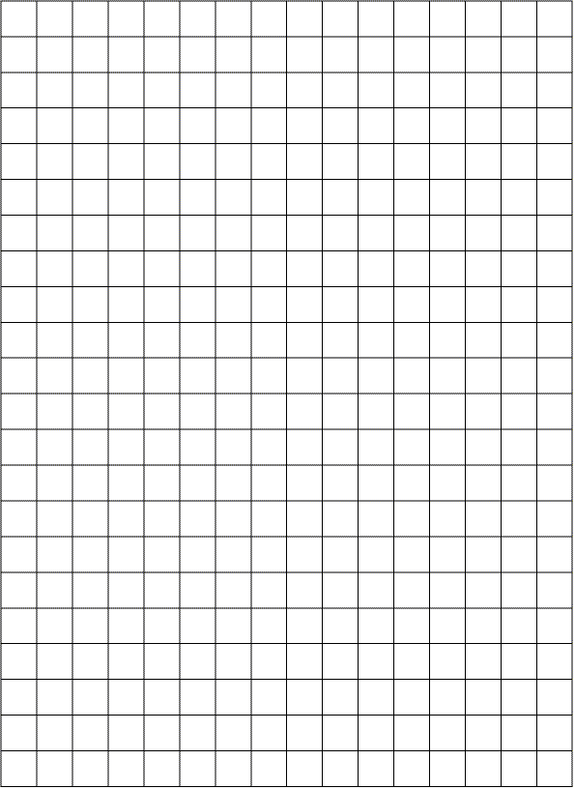

The guests put their coats in the cloak room. Each guest was given a ticket, can you put the tickets in order from lowest to highest?

_____ _____ _____ _____ _____ _____

_____ _____ _____ _____ _____ _____

Now can you show how many hundreds (H), tens (T) and units (U) there are in each ticket on the chart below

H | T | U

If you add all the tickets together, what number does this make? __________

(HINT: partition the numbers before you add them)
Whoops!!!! The person in the cloak room has dropped all of the tickets. You need to help them put all the tickets back into the correct order.

Here are the numbers on the tickets

_____ _____ _____ _____ _____ _____ _____ _____

Now can you put the tickets between the correct tickets.

_____ _____ _____ _____ _____ _____

_____ _____ _____ _____ _____ _____

_____ _____ _____ _____ _____ _____

_____ _____ _____ _____ _____ _____

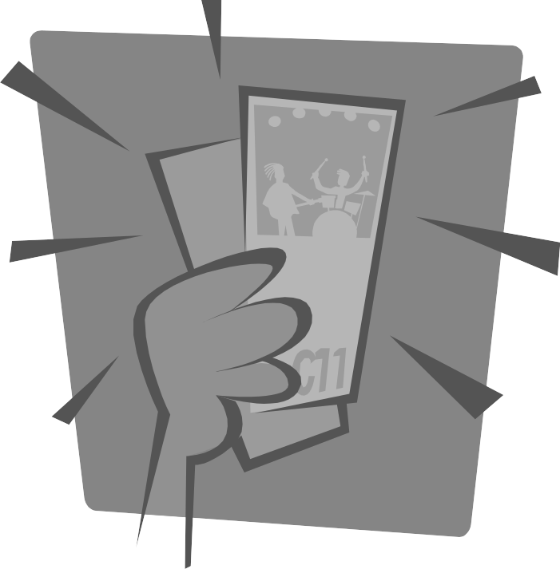
If you have the numbers __________________

How many different cloak room tickets can you make?

(HINTS: YOU CAN ONLY USE THE NUMBERS ONCE FOR EACH NUMBER
YOU CAN MAKE NUMBERS WITH DIFFERENT AMOUNTS OF DIGITS IN THEM)

Write you different answers below….

How many different tickets could you make? _____

_____ of your guests have brown hair. How many guests have brown hair? ______

How many guests don’t have brown hair? _______

_____ of your guests have curly hair. How many guests have curly hair? ______

How many guests don’t have curly hair? _______
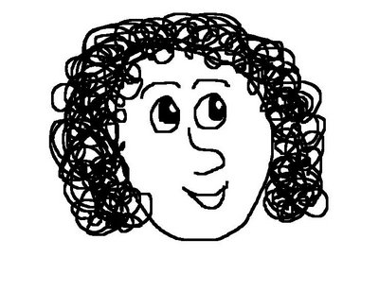
_____ of your guests have blue eyes. How many guests have blue eyes? ______

How many guests don’t have blue eyes? _______

_____ of your guests are on time. How many guests are on time? ______

How many guests aren’t on time? _______
_____ guests are wearing glasses. What fraction of guests are wearing glasses? _____

_____ guests are drinking cola. What fraction of guests are drinking cola? _____

_____ guests are wearing socks. What fraction of guests are wearing socks? _____

The guests are wearing party hats. Look at the party hats below…
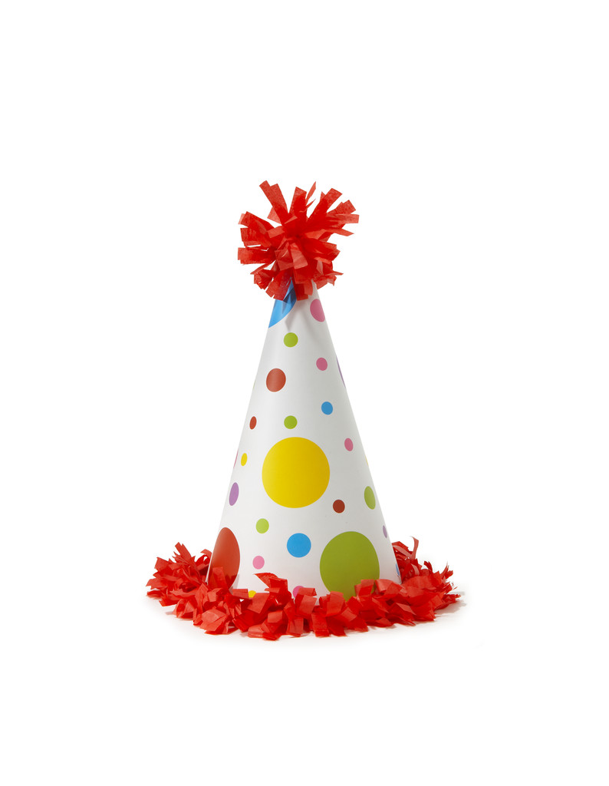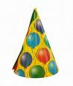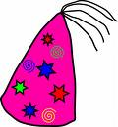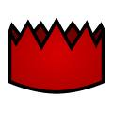
Now cut out the party hats and make a Venn diagram to stick the hats onto, on the next page
Draw your Venn diagram for the hats on this page
(HINT: YOU CAN TURN THE PAGE ROUND)

There are between 30 and 50 cakes.

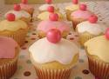

To count them quickly I first counted them in fours. There were two left over.

Then I counted them in fives. There was one left over.

How many cakes are there? _______

(HINT: 1ST WORK OUT THE NUMBERS IT COULD BE BETWEEN 30 AND 50 WHEN COUNTING IN FOURS AND FIVES
2ND WORK OUT THE DIFFERENCE BETWEEN THE AMOUNT LEFT OVER
3RD FIND THE NUMBERS THAT HAVE THIS DIFFERENCE)

You will never believe this! An elephant has walked into the party.
The elephant is __________ long. The room is _______ long. How many elephants could you get into a line? ________

There are ________ balloons. Each guest can have _______ balloons each.

If each guest has ______ party blowers. How many party blowers would you need? ______
Colour in each balloon a different colour.

Each guest is going to have ______ balloons each.

What are the different combinations of balloons they can each have? Draw a table below to show the different combinations. (USE A RULER!)

Here are some of the ages of the guests.

_____ _____ _____ _____ _____ _____ _____

_____ _____ _____ _____ _____ _____ _____

_____ _____ _____ _____ _____ _____ _____

Sort their ages into the Carroll Diagram below

I have ______ lollipops.

Cut out the number of lollipops you need and stick ______ on each plate.



Stick the same amount of lollipops on each plate.
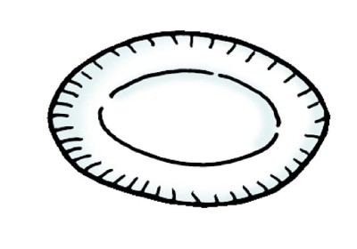

How many lollipops are on each plate? _______

How many lollipops are remaining? _______

Now write the sum to show the problem you just worked out _________________

Where is the DJ? We need some music!

He said he was going to be here at 7pm! It is now

______ o’clock!

By how much time is he late? ________

He said he was going to play for _________.

What time will he finish if he starts at ________?

__________

The party needs to finish at _______________

Will he have enough time to play all his music?

____________
Today is the _____________________

My party is on the _____________

How many days until my party? __________

If my party is on a ____________

And there are ______ days until my party, what

day is it today? _________

If there were _______ days to my party, how

many hours would this be? ________

I’M SO EXCITED!!

