It’s Party Time!
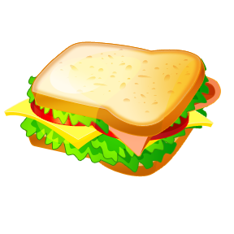
Party hats Sandwiches Crisps Hotdogs Pizzas

each each each each each  
Coke Lemonade Ice creams Cakes Balloons

each each each each each

You are having a party for people. You have ONLY to spend. Everybody must have a balloon, a party hat, a drink and AT LEAST 2 things to eat.
Work out what you can buy, how much money you will spend altogether and how much money you have left.

I can buy:

Altogether I spend

I have left.

